Let’s Get Out and About!

Jubilee Special May Half-Term Newsletter 2022

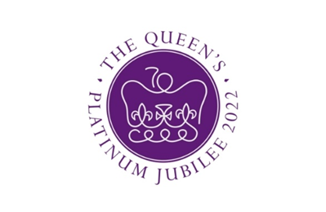

Welcome to the Jubilee edition of Let’s Get Out and About! In this edition, you will find out more about what’s on in your local area this May half term including a special focus on activities for the family during the Jubilee weekend. Please remember to check the websites of venues before visiting as in some cases advance booking may be required.

SPOTLIGHT ON: Celebrating the Queen’s Jubilee in Ealing
Come and join your neighbours in celebrating 70 years of Her Majesty’s reign. As part of the Platinum Jubilee celebrations, Ealing Council has planned a series of free events during the extended bank holiday weekend (2 – 5 June) to bring our communities together, make connections and share each other’s culture.

On Thursday 2 June, beacons will be lit in Walpole Park in Ealing and at Northala Fields in Northolt at 9.15pm. If you wish to attend, please arrive by 9pm.

On Sunday 5 June, free activities in Walpole Park will include music and dance on stage as part of the Big Jubilee Lunch from 12noon until 5pm, followed at 7.30pm by the Prom in the Park with Ealing Symphony Orchestra’s 60+ musicians and guest singer – all rounded off by fireworks for a platinum finale. To book free tickets for Prom in the Park click here Eventbrite.

For more information about any of these events please go to the Council’s website Ealing Platinum Jubilee Celebrations

Library Crafts
Libraries across Ealing will be hosting a variety of craft sessions over the May half-term
break. Activities are free and there is no need to book.

Jubilee Craft Session | Acton Library | Tuesday 31 May  11.00am & 2.00pm
Elmer Day | Southall Library | Saturday 28 May  2.00pm
Union Jack Bunting | Northolt Leisure Library | Saturday 28 May  2.00pm
Making crowns and greetings cards | Ealing Central Library | Saturday 28 May  2.00pm

For more information go to What’s on Ealing Libraries | Ealing Council

Make and Take - Jubilee Special
Get creative with Art Jar to celebrate the Queen's Jubilee at Gunnersbury Park Museum

Art Jar is a local arts organisation bringing communities together through the arts. They will be hosting workshops to make your own crown - fit for kings & queens, 3D model castles, celebratory flags and a keepsake memento to remember this special occasion.

11.00am – 3.00pm on the 2, 3, 4 and 5 June. Free, no need to book, just turn up. For more info go to the website Gunnersbury-Make-&-Take

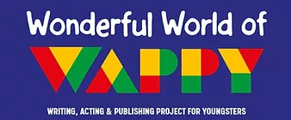
WAPPY
Building Bridges Workshop
Saturday 28 May 2.00pm – 4.00pm Acton Library

Creative workshops for children and young people, aged between 4 and 16 years old. Based around the theme of ‘Building a Bridge’ the sessions aim to bring young people together from diverse ethnic groups/social backgrounds, with varying skills and abilities to engage them in teamwork, problem-solving, and ‘hands-on’ construction activities to develop a range of creativities, to be presented, exhibited and showcased.

The project also includes a Community Games Day in Walpole Park (2-5 pm; Saturday, August 2nd) plus hosting an End of Project Showcase (which will be attended by a celebrity guest artist).

Other dates available after half-term: 11 and 25 June; 2, 9, 16 and 23 July. 30 July 12.00 – 5.00pm Session and Show. Please note: Families who are residents in Central Acton and its neighbouring areas will be prioritised, though exceptions can be made for existing WAPPY members and new siblings.
If interested, please download the registration form here Registration Form

Writing What I Love About Ealing
Sunday 29 May 11.30am – 1.00pm
OPEN Ealing, Unit 14 Dickens Yard

This workshop aims to create a safe space for aspiring, new and seasoned young writers to create written and visual narratives. It is aimed at young people aged 8 - 16 years; parents/carers & WAPPY volunteers welcome.
Preparation: Attendees are asked to bring one favourite item to this workshop.
To register go to Writing What I Love About Ealing Tickets, Sun 29 May 2022 at 11:30 | Eventbrite
For more information about either of the above workshops please contact wappy@live.com

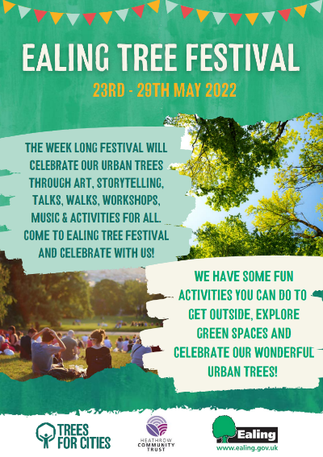
Ealing Tree Festival
Saturday 28 May 10.00am – 3.00pm - Southall Park Saturday
Sunday 29th May 10.00am – 3.00pm - Litten Nature Reserve

Come and join us for a fun filled weekend celebrating all things tree! Activities will include storytelling, tree wishes, tree walks, nature mask making, wildlife discovery, music, tree doctor, leaf printing, sensory table and much more!

For more information download the leaflet Ealing-Tree-Festival-Activities-compressed.pdf

Sotheby’s Jubilee Arts Festival: Family Day Saturday 4 June, 12:00–5:00pm

Kick start your Jubilee weekend and drop in to our free family festival, where children’s authors, artists and performers bring the historic moment to life through readings, performances and art trails. Activities include:
The Royal Trail 12:00–4:00pm
Pick up a children’s activity sheet with puzzles on magnificent monarchs and fuzzy friends.
Drop-in
Poetry Workshop for Older Teens with Theresa Lola 1:00pm
Entitled ‘I Come from Everywhere’, this workshop is about writing poems to spectacularly introduce us to the world. We will explore the places, cultures, music, events and other things that have individually and collectively shaped us into who we are. This workshop is aimed at 14 - 18 year olds.
Book here
A Reading with Michael Morpugo 2:00pm
Join Michael Morpugo as he reads his new book, There Once Is A Queen, illustrated by Michael Foreman, telling the story of Queen Elizabeth II’s life beginning with planting an oak tree with her father as a child.
Book here
Battle of the Bears: Winnie the Pooh vs Paddington Debate with Intelligence Squared 3:00pm
In this family-friendly debate, we pit two of the most beloved characters of British children’s fiction against each other Winnie-the-Pooh and Paddington Bear. The debate will be chaired by Nicolette Jones, author and children’s book editor of The Sunday Times. Join us for an event that will appeal to bear lovers of all ages.
Book here
Charlie Mackesy Drawing Station 12:00–4:00pm
The illustrations of artist and author Charlie Mackesy are celebrated for distilling life’s fundamental truths and pleasures. To accompany a selling exhibition of original works depicting characters from his bestselling book The Boy, the Mole, the Fox and the Horse, children can express their creativity with colouring sheets created by Mackesy.
Drop-in

For more information go to Jubilee Arts Festival | Art Auction & Sales | Sotheby's (sothebys.com)

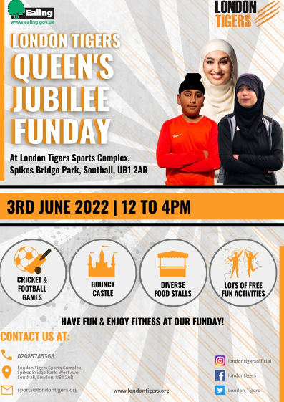
London Tigers Queen’s Jubilee Funday
Friday 3 June 12 – 4pm

Have fun and enjoy fitness at our funday!

Come along and join in cricket and football games, have a jump on the bouncy castle and much more! Diverse food stall available and lots of free, fun activities.

For more information contact 020 8574 5368 or email sports@londontigers.org See website www.londontigers.org

Discovery Days: Royal Parks Celebration
Tuesday 31 May & Wednesday 1 June 2022
11am - 3pm

Celebrate the Queen’s Platinum Jubilee by exploring the past, present, and future of the Royal Parks with hands-on activities that will inspire you and your little ones to protect and preserve your parks for the next 70 years!

Join us at Hyde Park and create your very own nature crown, plant seeds, and design a park of the future. Enjoy a special storytelling session about the royal history of the parks and their connection to the Queen. The activities are suitable for the whole family to enjoy, allowing you and your children to connect with nature together (and giving you the chance to find your inner child!).

To register your interest to attend please go to Discovery day: Royal celebration - Hyde Park - The Royal Parks. If you have any questions please see Frequently Asked Questions FAQ’s page

This newsletter was compiled by the School Partnerships and Enrichment Team, Ealing Council. All information was correct at the time of compilation but please use the weblinks provided to check dates and times before joining an activity. Please contact sthompson@ealing.gov.uk for any suggestions or feedback.

