LAND ACTIVITIES
COMPLETE & RETURN THESE FORMS TO POOL@JACKTIZARD.LBHF.SCH.UK TO BOOK

Full name of young person:
Their age: |  | Their Disability:
Address:
Postcode: |  | Borough:
School (if applicable):
Contact Number:
Contact Email address:
Name & Age of any siblings attending: | 1. |  | 4.
 | 2. |  | 5.
 | 3. |  | 6.
Name of parent/carer attending:
ON THE NEXT PAGES - PLEASE TICK WHICH SESSIONS YOU WOULD LIKE TO ATTEND.

ONCE WE HAVE RECEIVED YOUR COMPLETED FORM WE WILL BE IN TOUCH TO CONFIRM YOUR PLACE. WHERE PLACES ARE LIMITED, A WAITING LIST WILL BE CREATED.

SPACES ARE LIMITED IN SPECIAL YOGA & BUBBLELAND
STAY & PLAY ACTIVITIES INCLUDE:
- PLAYGROUND USE INCLUDING WHEELCHAIR ACCESSIBLE ROUNDABOUT
- TUFF TRAY SENSORY ACTIVITIES
- SELECTED ARTS & CRAFTS
- USE OF SOFT PLAY ROOM
PARENTS OR CARERS MUST STAY WITH THE CHILD FOR THE DURATION OF YOUR VISIT.
Page 1 of 3 to complete

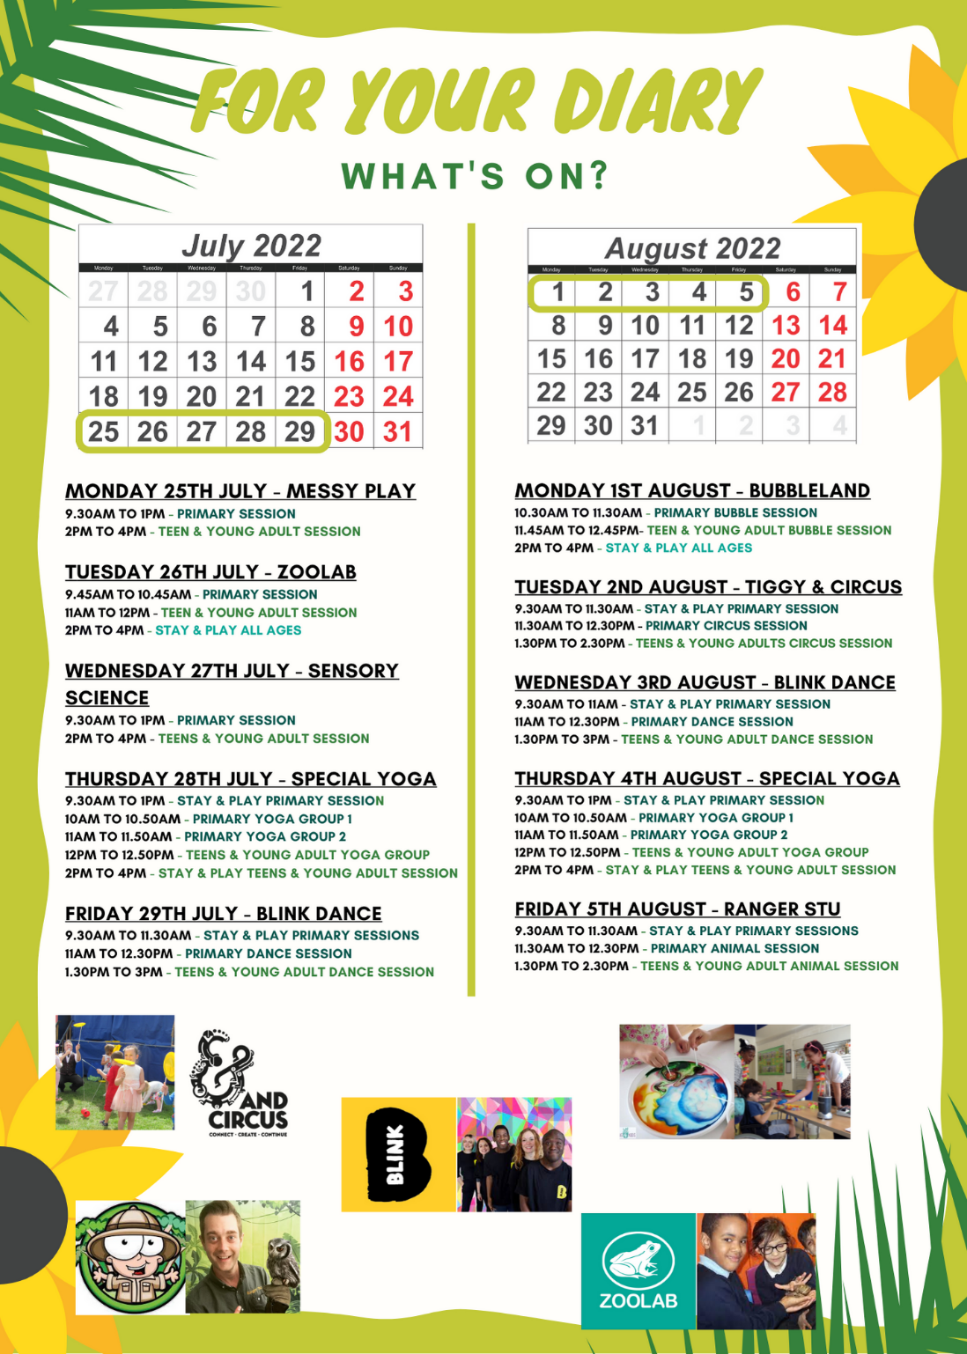

Week 1 – Booking Form
Primary Ages = 3 years to 12 years Teen & Young adult Ages = 12 years to 25 years
Monday 25th July
☐ 9.30am to 1pm – Primary MESSY PLAY session
☐ 2pm to 4pm – Teen & Young adult MESSY PLAY session
Tuesday 26th July
☐9.45am to 10.45am – Primary ZOOLAB session
☐ 11am to 12pm – Teen & Young adult ZOOLAB session
☐ 2pm to 4pm – Mixed ages STAY & PLAY
Wednesday 27th July
☐9.30am to 1pm – Primary SENSORY SCIENCE session
☐ 2pm to 4pm – Teen & Young adult SENSORY SCIENCE session
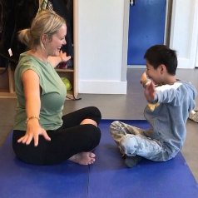
Thursday 28th July
☐9.30am to 1pm – Primary STAY & PLAY session
☐ 10am to 10.50am – Primary YOGA group 1
☐11am to 11.50am – Primary YOGA group 2
☐ 12pm to 12.50pm – Teen & Young adult YOGA group
☐2pm to 4pm – Teen & Young adult STAY & PLAY session
Friday 29th July
☐ 9.30am to 11.30am – Primary STAY & PLAY session
☐ 11am to 12.30pm – Primary BLINK DANCE session
☐ 1.30pm to 3pm – Teens & Young adults BLINK DANCE session
Page 2 of 3 to complete
Week 2 – Booking Form
Primary Ages = 3 years to 12 years Teen & Young adult Ages = 12 years to 25 years
Monday 1st August
☐ 10.30am to 11.30am – Primary BUBBLELAND session
☐ 11.45am to 12.45pm – Teen & Young adult BUBBLELAND session
☐ 2pm to 4pm – Mixed ages STAY & PLAY
Tuesday 2nd August
☐ 9.30am to 11.30am – Primary STAY & PLAY session
☐ 11.30am to 12.30pm – Primary &CIRCUS session
☐ 1.30pm to 2.30pm – Teen & Young adult &CIRCUS session
Wednesday 3rd August
☐ 9.30am to 11am – Primary STAY & PLAY session
☐ 11am to 12.30pm – Primary BLINK DANCE session
☐ 1.30pm to 3pm – Teens & Young adult BLINK DANCE session
Thursday 4th August
☐9.30am to 1pm – Primary STAY & PLAY session
☐ 10am to 10.50am – Primary YOGA group 1
☐11am to 11.50am – Primary YOGA group 2
☐ 12pm to 12.50pm – Teen & Young adult YOGA group
☐2pm to 4pm – Teen & Young adult STAY & PLAY session
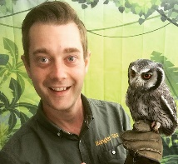
Friday 5th August
☐ 9.30am to 11.30am – Primary STAY & PLAY session
☐ 11.30am to 12.30pm – Primary RANGER STU ANIMAL session
☐ 1.30pm to 2.30pm – Teen & Young adult RANGER STU ANIMAL session
Page 3 of 3 to complete
Please sign & return to pool@jacktizard.lbhf.sch.uk

