Sexual violence and sexual harassment

between young people policy 2021.

Date Implemented | November 2021 | Revision due date: | November 2023
Governor Committee and date (where applicable) | Curriculum | Frequency of review: every two years.
Reviewed by:  Date: | David White (DSL)
Authorised by Governors:  Date: | November 2021
Related Documents/Policies

Read in conjunction with:
Behaviour for Learning Policy (2021)
Safeguarding Policy (2021)
e Safety policy (2021)
PSHCE and RSE policy (2021)
Anti-bullying Policy (2021)

CONTENTS Pages

AIMS & VALUES 3

CONTEXT 4

STATEMENTS OF PRINCIPLE 4

TERMS & PHRASES 5

THE LAWS RELEVANT TO ONLINE SEXUAL HARASSMENT IN ENGLAND 6

WHATS THE IMPACT OF ONLINE SEXUAL HARASSMENT? 7

PREVENTION 8

REPORTING, RECORDING & ACTIONING CONCERNS 9

MONITORING & REVIEW 9

Appendix

- School: initial action flow chart for dealing with a student disclosure 12

- Guidance for students and parents 25

This advice should not be read in isolation. It is important for us to consider other relevant advice and guidance, including the following as part of our approach to protecting children from sexual violence and sexual harassment:
- Exclusions From Maintained Schools, Academies and PRUs (statutory guidance)
- Keeping Children Safe in Education (statutory guidance)
- Sex and Relationship Education (statutory guidance for maintained schools and academies)
- Working Together to Safeguard Children (statutory guidance)
- Behaviour and Discipline in Schools (advice for schools)
- Children Missing Education (advice for schools)
- Cyberbullying (advice for schools)
- Equality Act 2010 and Public Sector Equality Duty (advice for schools)
- Mental Health and Behaviour in Schools (advice for schools)
- Preventing and Tackling Bullying (advice for schools)
- The Equality and Human Rights Commission (provides advice on avoiding discrimination in a variety of educational contexts). Schools must be aware of their obligations under the Human Rights Act 1998 (HRA). It is unlawful for schools to act in a way that is incompatible with the European Convention on Human Rights.
- Schools and colleges are required to comply with relevant requirements as set out in the Equality Act 2010 (the Equality Act) see advice for schools Provisions within the Equality Act allow schools to take positive action, where it can be shown that it is proportionate, to deal with particular disadvantages affecting one group.
- UKCCIS Sexting advice (advice for schools and colleges)
- Compliance with the Public Sector Equality Duty (PSED) is a legal requirement for schools and colleges that are public bodies and therefore have a general duty to have regard to the need to eliminate unlawful discrimination, harassment and victimisation, to advance equality of opportunity between different groups and to foster good relations between different groups. The duty applies to all protected characteristics and means that whenever significant decisions are being made or policies developed, thought must be given to the equality implications such as, for example, the elimination of sexual violence and sexual harassment.

AIMS AND VALUES

The school’s vision is to ensure that all students can ‘achieve excellence in a learning community.’ As a school we are committed to nurture and develop all of our students in a safe environment. We are a happy and caring school that values diversity and celebrates individuality.

We work hard to develop our key values and student attributes in our staff and students.
Determination
Curiosity
Freedom
You will not give up when things are difficult. You will keep going until you find the solution to a problem. You have a strong desire to learn. You want to find out more. You understand freedom is choice. Freedom is where rights are balanced with responsibilities.
Resilience
Unity
Positivity
You are able to withstand stress and bounce back after a setback. You are part of a community. You will work with us to achieve our shared goal of excellence. You have a confident outlook on life.
Compassion
Respect
Responsibility
You understand the feelings of others and have a desire to help others. You know you are unique and valuable. You will listen to others and know others are valuable too. You will do your share of the work and help others when they need help. You also have the responsibility to make a better world.

CONTEXT
Sexual violence and sexual harassment can occur between two children of any age and sex. It can also occur through a group of children sexually assaulting or sexually harassing a single child or group of children.

Sexual violence and sexual harassment exist on a continuum and may overlap, they can occur online and offline (both physically and verbally) and are never acceptable. All victims will be taken seriously and offered appropriate support.

Children who are victims and survivors of sexual violence and sexual harassment will find the experience stressful and distressing. This will, in all likelihood, adversely affect their educational attainment. We will ensure that victims and survivors are protected, offered appropriate support and every effort is made to ensure their education is not disrupted. Other children and school staff will be supported and protected as appropriate.

The UK report It’s just everywhere (2017) found that girls in particular are more likely to be victimised with unwanted sexual behaviour such as messages and images from their peers online, with 31% of female respondents aged 13-17 years saying they had experienced this in the last year compared to 11% of male respondents.

Children with Special Educational Needs and Disabilities (SEND) are three times more likely to be abused than their peers. Additional barriers can sometimes exist when recognising abuse in SEND children. These can include:

  - assumptions that indicators of possible abuse such as behaviour, mood and injury relate to the child’s
disability without further exploration;
  - the potential for children with SEND being disproportionately impacted by behaviours such as bullying and harassment, without outwardly showing any signs; and
  - communication barriers and difficulties overcoming these barriers.

Children who identify as LGBTQQIP2SAA (lesbian, gay, bisexual, transgender, questioning, queer, intersex, pansexual, two-spirit (2S), androgynous and asexual) can be targeted by their peers. In some cases, a child who is perceived by their peers to be LGBTQQIP2SAA (whether they are or not) can be just as vulnerable as children who identify as LGBTQQIP2SAA .

STATEMENT OF PRINCIPLES
At Elthorne Park High school, we take a whole school approach to safeguarding and child protection. This means involving everyone in the school, including the governing body, all the staff, children, and parents and carers. Our approach to sexual violence and sexual harassment therefore reflects and is part of the broader approach to safeguarding.

All staff, pupils and parents should be aware of the importance of:
  - making clear that sexual violence and sexual harassment is not acceptable, will never be tolerated and is not an inevitable part of growing up;
  - not tolerating or dismissing sexual violence or sexual harassment as “banter”, “part of growing up”, “just
having a laugh” or “boys being boys”;
  - challenging behaviour (potentially criminal in nature), such as grabbing bottoms, breasts and genitalia and flicking bras and lifting up skirts. Dismissing or tolerating such behaviours risks normalising them; and
  - understanding that all of the above can be driven by wider societal factors beyond the school, such as everyday sexist stereotypes and everyday sexist language
TERMS AND PHRASES

Harmful sexual behaviour
Children’s sexual behaviour exists on a wide continuum, from normal and developmentally expected to
inappropriate, problematic, abusive and violent. Problematic, abusive and violent sexual behaviour is
developmentally inappropriate and may cause developmental damage. A useful umbrella term is “harmful sexual behaviour”. Harmful sexual behaviour can occur online and/or offline and can also occur simultaneously between the two. Harmful sexual behaviour is considered in a child protection context.
When considering harmful sexual behaviour, ages and the stages of development of the children are critical factors to consider. Sexual behaviour between children can be considered harmful if one of the children is much older, particularly if there is more than two years’ difference or if one of the children is pre-pubescent and the other is not. However, a younger child can abuse an older child, particularly if they have power over them, for example, if the older child is smaller in stature.

Sexual violence
When referring to sexual violence in this policy, we do so in the context of child on child sexual violence and referring to sexual offences under the Sexual Offences Act 2003

What is consent?
Consent is about having the freedom and capacity to choose. Consent to sexual activity may be given to one sort of sexual activity but not another. Consent can be withdrawn at any time during sexual activity and each time activity occurs.
- a child under the age of 13 can never consent to any sexual activity;
- the age of consent is 16;
- sexual intercourse without consent is rape.

Sexual harassment
Sexual harassment is unwanted conduct of a sexual nature between children that can occur online and offline. Sexual harassment (as set out below) creates an atmosphere that, if not challenged, can normalise inappropriate behaviours and provide an environment that may lead to sexual violence. Sexual harassment is likely to: violate a child’s dignity, and/or make them feel intimidated, degraded or humiliated and/or create a hostile, offensive or sexualised environment. Sexual harassment can include:
  - sexual comments, such as: telling sexual stories, making lewd comments, making sexual remarks about clothes and appearance and calling someone sexualised names;
  - sexual “jokes” or taunting;
  - unwanted touching;
  - physical behaviour, such as: deliberately brushing against someone, interfering with someone’s clothes (schools and colleges should be considering when any of this crosses a line into sexual violence - it is important to talk to and consider the experience of the victim) and displaying pictures, photos or drawings of a sexual nature; and
  - online sexual harassment.
Online sexual harassment refers to a range of behaviours where digital technologies are used to facilitate both virtual and face-to-face sexually based harms. Online sexual harassment may constitute a number of criminal offences, depending on the nature of the online harassment. Whether the conduct constitutes a criminal offence or not, many victim-survivors experience these behaviours as a form of sexual violence. Examples of online sexual harassment can be broadly split into the following areas:
  - Unsolicited sexual content online refers to any sexual content shared online which is not wanted by the recipient. This could include content seen on apps, messaging services and websites which has not been sought out by the user.
  - Image-based sexual abuse refers to the non-consensual creation and/or distribution of sexual images.
  - Sexual coercion, threats and intimidation online could include a person receiving threats of a sexual nature or being coerced to engage in sexual behaviours on or offline via digital technologies.
While there are distinctions between these three categories above, there are evident overlaps and links.
It is important to be aware of some of the terms that are regularly used by the general public and the media when reporting on cases and the impact that the use of these terms may have on victims and survivors of sexual abuse/harassment/violence.

Victims and survivors rather than ‘victims’ or ‘survivors’
Both these words have very different connotations and varying personal meanings for individuals. Some people identify as victims and some as survivors, therefore it is important to use the words ‘victims and survivors’ together when collectively referring to people that have been subjected to sexual violence and/or sexual harassment.

Alleged perpetrator
For the purpose of this document we will use the term ‘alleged perpetrator’ and where appropriate ‘perpetrator’.
These are widely used and recognised terms and the most appropriate to aid the effective writing of policies. Adults should, however, think very carefully about terminology, especially when speaking in front of children.

THE LAWS RELEVANT TO ONLINE SEXUAL HARASSMENT IN ENGLAND

Unsolicited sexual content online
There are a number of laws in which a person could be prosecuted for sending unsolicited sexual content online, however, the act in and of itself is not yet illegal in England and Wales (though it is in Scotland). Laws which could be applied to this include the Protection from Harassment Act 1997 and some aspects of the Sexual Offences Act 2003 such as ‘causing a child to watch a sex act’ and ‘sexual communication with a child’.

Image-Based Sexual Abuse
As of 2015, it is ‘an offence for a person to disclose a private sexual photograph or film if the disclosure is made
without the consent of an individual who appears in the photograph or film, and with the intention of causing
that individual distress’. In April 2017, the Sentencing Council included the ‘threat to disclose intimate material or sexually explicit images’, within its guideline for offences under the Communications Act 2003 (7); however, prosecuting threats of image-based sexual abuse remains challenging.
Under the Protection of Children Act 1978, creating or sharing indecent images of a child is illegal. It is illegal if the person creating the image is under the age of 18, even if they consent to it being created, or share it with
children of the same age. The Home Office Recording Rules ‘Outcome 21’ (January 2016) allows police to respond in a proportionate way to reports of youth produced sexual imagery. This states that even though a young person has broken the law and the police may have evidence that they have done so, the police can record that they chose not to take further action as it was not in the public interest
Since April 2019, it has been an offence to take an image or video up a person’s skirt without their consent, often referred to as ‘upskirting’.

Sexual coercion, threats and intimidation online
Several sections of the Sexual Offences Act 2003 could be relevant in instances of sexual coercion, threats and
intimidation including ‘causing or inciting a child to engage in sexual activity’. In situations of demands for sexual
images where threats are made, Section 21 of the Theft Act 1968 (Blackmail) is likely to apply.
All kinds of persistent harassment and stalking are offences under the Protection from Harassment Act 1997. What constitutes harassment or stalking is not explicitly defined, but can include a range of actions when considering the context, nature, and duration of the acts.

WHAT’S THE IMPACT OF ONLINE SEXUAL HARASSMENT?
The experience of online sexual harassment will of course be different for all young people. It is important to recognise that it can have both short- and long-term consequences for victims and survivors which will appear differently for each individual, impacting mental health and wellbeing.

What’s the impact of unsolicited sexual content for young people?
  - Severe mental distress - feeling threatened, intimidated and violated
  - Violates dignity and autonomy of victims and survivors - it removes the right to control what we see and engage with online
  - Leads to older siblings (who are still children) monitoring the content on younger siblings’ social media platform to remove any unsolicited content. This puts additional pressure on older siblings to keep younger siblings safe.
  - Normalisation of non-consensual sexual activity and intimidation.

What’s the impact of image-based sexual abuse (IBSA) for young people?
  - Severe mental distress - feeling threatened, violated and anxious regarding repercussions including fearing direct physical attacks, to name but a few
  - Violates dignity and privacy of victims - it removes right to control who we share intimate images with
  - Impacts on feelings of self-worth and self-esteem levels: IBSA can relate strongly to issues of body image and self-esteem
  - Takes away right to freedom of sexual expression - feelings of shame from culture of blaming victim for their own abuse
  - Normalisation of non-consensual sexual activity and sexual violence
  - Social stigma can negatively impact peer relationships leading to risk of isolation
  - School refusal if issues of social stigma begin to prevent a young person from feeling comfortable in the school setting
  - Victims fear chances of employment and other opportunities will be put at risk if images are put online or if there is police involvement.

What’s the impact of sexual coercion, threats and intimidation for young people?
  - Severe mental distress - feeling threatened, violated and anxious regarding repercussions including fearing direct physical attacks, to name but a few
  - Violates dignity and privacy of victims - it removes right to control what we do online
  - Impacts on feelings of self-worth and self-esteem levels: threatening IBSA can relate strongly to issues of body image and self-esteem
  - Normalisation of non-consensual sexual activity and sexual violence
  - Victim’s fear chance of employment and other opportunities will be put at risk if employers or potential
employers find images and police involvement
PREVENTION
The school plays an important role in preventative education. Keeping Children Safe in Education sets out that all schools should ensure children are taught about safeguarding, including how to stay safe online. The school’s PSHCE curriculum provides information and guidance for students on online safety across each year group and individual subject areas also address issues relating to online concerns. Assemblies and tutor time are also used to discuss key themes that follow on from online safety and issues that relate to sexual violence and harassment.
Addressing inappropriate behaviour can be an important intervention that helps prevent problematic, abusive and/or violent behaviour in the future. Children displaying harmful sexual behaviour have often experienced their own abuse and trauma. It is important that they are offered appropriate support.
All staff are trained in approaches to help support and tackle issues of sexual harassment and sexual violence in schools and what to do if a concern is reported to them as part of their annual safeguarding training and in year training and information sharing.

A planned curriculum as part of a whole school approach
The school has a clear set of values and standards, and these will be upheld and demonstrated throughout all aspects of school life. This will be underpinned by the school’s behaviour policy, pastoral support structures and by a planned programme of evidence-based content delivered through the whole curriculum. This programme is mainly delivered at age appropriate stages during our weekly PSHCE lessons & assemblies; key themes addressed include:
  - healthy and respectful relationships;
  - what respectful behaviour looks like;
  - recognising and resisting pressure/seeking help;
  - consent;
  - gender roles, stereotyping, equality;
  - body confidence and self-esteem;
  - practising assertiveness techniques;
  - prejudiced behaviour;
  - recognising and managing risk;
  - understanding acceptable/unacceptable physical contact;
  - that sexual violence, abuse, coercive control and sexual harassment is always wrong; and
  - addressing cultures of sexual harassment;
  - human rights – the idea that all individuals have a right to fairness and to having their privacy respected;
  - digital defence - educating young people on how to navigate online platforms and digital devices safely and effectively. It can include aspects of digital literacy related to privacy settings, reporting and blocking other users, identifying and addressing issues of online sexual harassment and recognising misinformation. Students should understand about:
    - Using technology including learning how to use and manage social media apps and web platforms. This includes supporting the creation of youth-led change-making and awareness raising resources and providing resources and commitment to youth led gender activism including girls’ rights and LGBTQ+ rights.
    - Online privacy (data protection) including how to use privacy settings on their most- used platforms (e.g. Instagram, Snapchat, Tiktok), and knowing how to identify fake profiles.
    - Digital defence strategies, such as reporting, blocking and being aware of the Internet Watch foundation, CEOP and Report Harmful Content (links below).
    - Being a bystander: providing young people with an understanding of what they could do if they witnessed someone being harassed or bullied.
Our school will deliver this content through planned, high-quality, Sex and Relationship Education (SRE) and Personal, Social, Health and Economic (PSHE) lessons; form time activities and assemblies; and Activity Days (when necessary). As part of our curriculum offer, we may engage with appropriate, well established external agencies to deliver materials to students.

REPORTING, RECORDING & ACTIONING CONCERNS
Students are encouraged to report a concern to any member of staff. They can do this in the following way:
- Speak to any member of staff. Students can speak directly to their tutor, Year Leader or Pastoral Support worker or any other staff member they feel comfortable approaching.
- Speak to one of the Designated Safeguarding Leaders:
Designated and Deputy Safeguarding Leads | Key Stage DSLs
Ms Brown | Key Stage 3
Mr Hardy or Ms Quinn | Key Stage 4
Ms Thomas | Key Stage 5
Other Designated Safeguarding Leads | Mr White - Deputy Headteacher  Mr Wong - Headteacher

Alternatively students may prefer to speak to:
- Their parents
- The School’s Safety Officer.

Recording a Disclosure
Staff are then required to follow reporting and recording procedures as outlined in the school’s child protection
and safeguarding policy.

The person receiving the disclosure must record their referral using the school’s electronic recording system
Myconcern, completing each section and using the body map provided as required. They must follow this with an
in person meeting with one of the school’s DSLs.

It is important to note that a staff member can also make a referral directly to children’s social care (Ealing) using
the following contact number using the following number. Ealing Children’s Integrated Response Service (ECIRS)
0208 825 8000. The staff member is also required to follow the school’s recording process using MyConcern as
well.

DSL actions following a disclosure
The DSL or Assistant DSL will meet with the student and follow actions outlined in the school’s initial actions flow chart - Brookes Traffic light process for dealing with reports of sexual harassment or violence (Appendix 1) The wishes of the victim throughout the process and confidentiality explained.
The report will be assessed by the DSL and actioned in line with guidance outlined in Keeping Children Safe (2021) in Education and Sexual violence and sexual harassment between children in schools and Colleges (September 2021) This may involve contact with external agencies and in some cases the police.
As part of this process, both the victim and the perpetrator will be supported as outlined in Keeping Children Safe (2021) in Education and Sexual violence and sexual harassment between children in schools and Colleges (September 2021)
The DSL will ensure that accurate records of all incidents of sexual violence and harassment are logged on MyConcern.
Fore cases of sexual violence, the school will contact the Local Authority LADO to request a strategy meeting and guidance on next steps to ensure all students are kept safe.
Where the police are investigating, the school will suspend its own investigation until told to continue by the investigating officer, LADO or the strategy meeting lead.

MONITORING, EVALUATION AND REVIEW

This policy will be promoted and implemented throughout the school in the following ways:
- Safeguarding training
- Student assemblies & tutor time
- Website and school newsletters & bulletins – access to this policy and related support guidance links is available on the school’s website.

All incidents of sexual violence and harassment are logged on MyConcern and are and reported to the Governors at regular intervals. Stakeholders will be asked to contribute to policy review.

The Governing Body will monitor incidents of sexual violence and harassment that do occur, and review the
effectiveness of this policy and the school’s strategies.

The Governing Body supports the all attempts to eliminate sexual violence and harassment from the school. The Governing Body will not condone any sexual violence and harassment at all, and any incidents that do occur will be taken very seriously, and dealt with appropriately.

A parent/carer who is dissatisfied with the way the school has dealt with an incident can make a complaint using the school’s complaints policy available on the school website.

Appendix 1 - School: initial action flow chart for dealing with a student disclosure

Disclosure is made
The victim should be reassured. Confidentiality must not be promised. The allegation must be immediately reported to the DSL (or deputy) and an Initial Response Record started.

Victim(s)
Immediate provision must be made for their physical and emotional safety. This may include being removed from lessons and offered a safe space in school. They should then be given the opportunity to write a statement (or to explain their allegation to a trusted adult of their choosing who will keep a record) using a Student Statement Form. This may need to take place later in the presence of a family member.
Alleged perpetrator(s)
The DSL will make an immediate Risk Assessment and take action to ensure the safety of the victim, perpetrator, other students and staff. The Brook Traffic Light Tool appropriate to the age or stage of the alleged perpetrator should be referred to when assessing risk and need. This may include the immediate isolation of the alleged perpetrator(s).
Staff receiving disclosure
Staff must be given the time and space to write their account of the disclosure as soon as is practicable. They must be advised to write in detail and to indicate where they have used the student’s words verbatim. This should be recorded on a Staff Statement Form.

Decision to involve other agencies
The DSL (or deputy) will collate all documents and create a Serious Incident Chronology to record all interactions and investigations. The DSL (or deputy) will discuss the allegations with the Headteacher or other suitably qualified member of SLT. A decision will be made as to whether the allegation can properly be managed internally or whether other agencies should be involved. Guidance on decision making is given below and further details can be found in Sexual violence and sexual harassment between children in schools and colleges, advice.

Victim(s)
Arrangements will be made for families to be notified of the allegation. Safety and support advice will be given to families and a member of SLT will be assigned as their main contact. A record will be kept on the Ongoing Support Record.
Alleged perpetrator(s)
Arrangements will be made for families to be notified of the allegation. Safety and support advice will be given to families and a member of SLT will be assigned as their main contact. A record will be kept on the Ongoing Support Record.
Staff receiving disclosure
The DSL or deputy will discuss the written statement given by the member of staff to ensure clarity. Support and guidance will be offered to the member of staff, including a named member of SLT for ongoing support if necessary.

Next steps
The DSL will lead on planning, to include:
Appropriate support for the victim(s) and staff and appropriate support and sanctions for the perpetrator(s).
Ongoing risk assessment and control measures.
Investigation of the allegation and decisions on next steps.

Sexual violence or harassment between children
Initial response record

Details of disclosure
Name of student(s) making disclosure
Disclosure made to |  | Date of disclosure
Time of incident |  | Location
Other adults present |  | Other students present
Summary of disclosure
Full statements must be written by all staff and students involved at the earliest appropriate opportunity

Initial action taken (To include the student(s) making the disclosure and the subject(s) of the disclosure)
Student | Action taken | By whom

Professionals involved
Professional / agency | Notified? | Reason | Method | Date | Time | Notified by
D.S.L.
Headteacher
Police
Social Care
Health

Notification to families
Student name | Notified via | Date of notification | Time of notification | Notified by

Record completed by
Signature
Date

2.2
Student name: ___________________________________________________________________
Reason for selection: Chronological age / Developmental stage
Completed by: ______________________________________ Date: _______________________

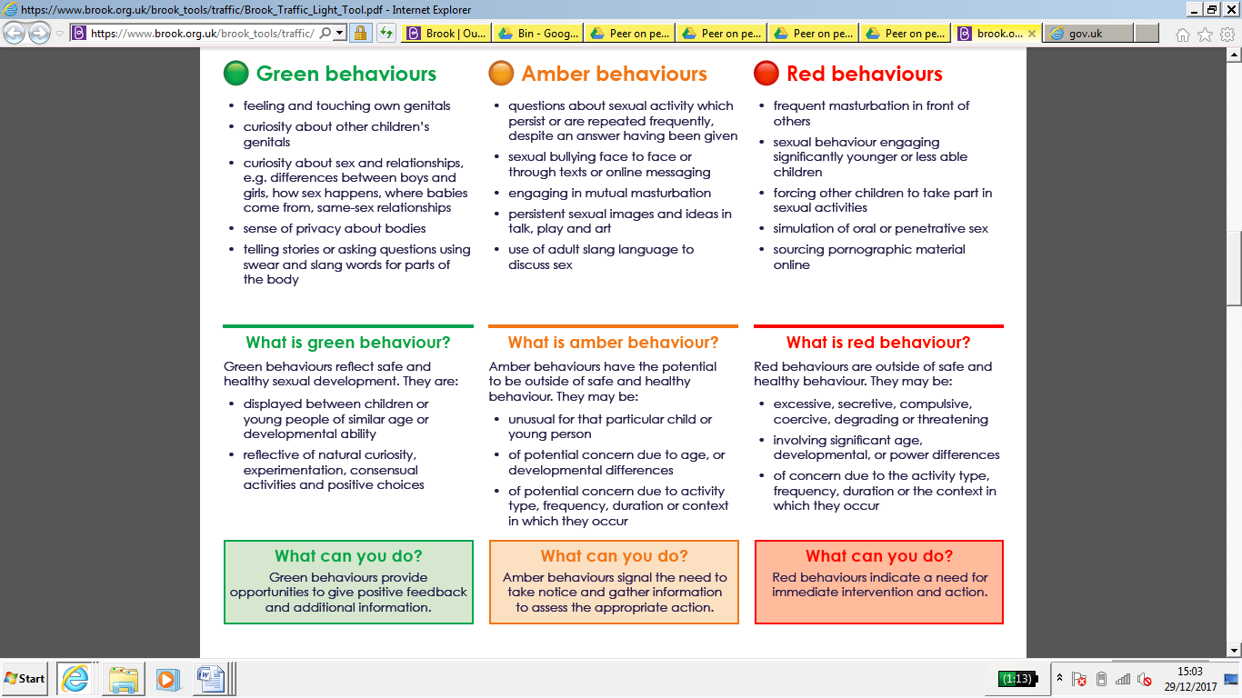

Student name: ___________________________________________________________________
Reason for selection: Chronological age / Developmental stage
Completed by: ______________________________________ Date: _______________________

Student name: ___________________________________________________________________
Reason for selection: Chronological age / Developmental stage
Completed by: ______________________________________ Date: _______________________

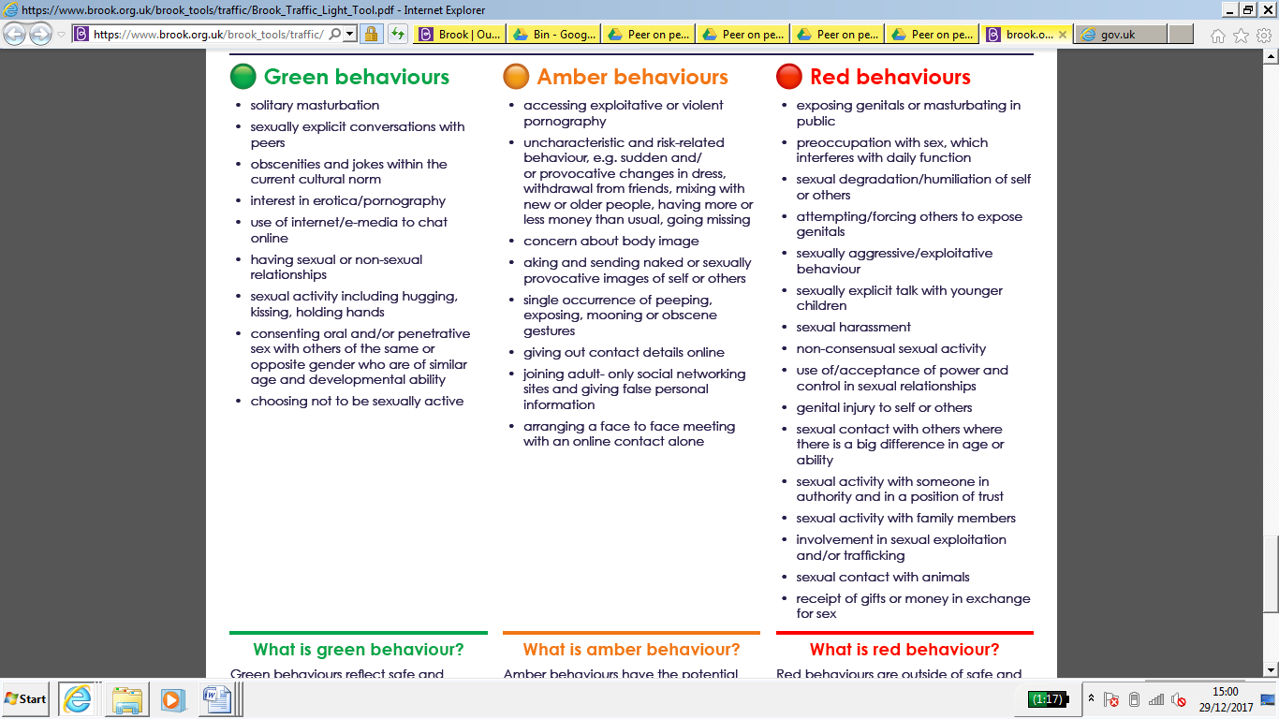
2.3
2.3 Serious Incident Chronology – peer on peer abuse
Date of incident
Location of incident
Brief summary of incident
Victim(s)
Alleged perpetrator(s)
Student witnesses
Staff witnesses
Lead member of staff investigating
Lead staff contact – victim(s)
Lead staff contact – perpetrator(s)
Other staff involved
Other professionals – victim(s)
Other professionals – alleged perpetrator(s)

This log must be stored securely along with any other documents and statements. A copy of the Peer on Peer Abuse Protocols, annotated to show actions taken, will also be included.

Date & time | Detail | Action | Resp. | Doc. ref. | Recorded by

2.5
Sexual violence or harassment between children
Ongoing support record – victim

Details of disclosure
Name of student
Assigned staff contact |  | Date of disclosure
Summary of disclosure

Student details
Vulnerability | Y / N? | Detail
S.E.N.D.
Medical
Emotional
Family
Peer group
Professionals involved
Professional / agency | Inv’d? | Contact name | Telephone / Email
D.S.L.
Headteacher
Police
Social Care
Health
CAMHS

Support plan
Area of need | Support plan | Lead professional | School contact (if applicable) | Date | Initials

2.6
Sexual violence or harassment between children
Ongoing support record – alleged perpetrator

Details of disclosure
Name of student
Assigned staff contact |  | Date of disclosure
Summary of disclosure

Student details
Vulnerability | Y / N? | Detail
S.E.N.D.
Medical
Emotional
Family
Peer group
Professionals involved
Professional / agency | Inv’d? | Contact name | Telephone / Email
D.S.L.
Headteacher
Police
Social Care
Health
CAMHS

Support plan
Area of need | Support plan | Lead professional | School contact (if applicable) | Date | Initials

Appendix 2 Sexual Harassment and Sexual Violence – Advice and Guidance for Parents and Students

The following links provide guidance and advice for students and parents about sexual harassment and
sexual violence:

- https://www.childline.org.uk/
- https://www.nspcc.org.uk/what-is-child-abuse/types-of-abuse/child-sexual-abuse/
- UKCCIS Sexting advice
- https://napac.org.uk/
- Sexual_violence_and_sexual_harassment_between_children_in_schools_and_colleges.pdf
- mind.org.uk/information-support/guides-to-support-and-services/abuse/
- parentzone.org.uk/article/sexual-abuse-schools-how-should-parents-respond
- sexualabusesupport.campaign.gov.uk/
- rapecrisis.org.uk
- Keeping Children Safe in Education
- Sex and Relationship Education
- https://safeguarding.network/content/safeguarding-resources/sexual-violence-sexual-harassment/

Other Guidance and Advice
- Working Together to Safeguard Children (statutory guidance)
- sharing-nudes-and-semi-nudes-advice-for-education-settings-working-with-children-and-young-people/sharing-nudes-and-semi-nudes-how-to-respond-to-an-incident-overview
- Children Missing Education (advice for schools)
- Cyberbullying (advice for schools)
- Equality Act 2010 and Public Sector Equality Duty (advice for schools)
- Mental Health and Behaviour in Schools (advice for schools)
- Preventing and Tackling Bullying (advice for schools)
- Compliance with the Public Sector Equality Duty (PSED)

