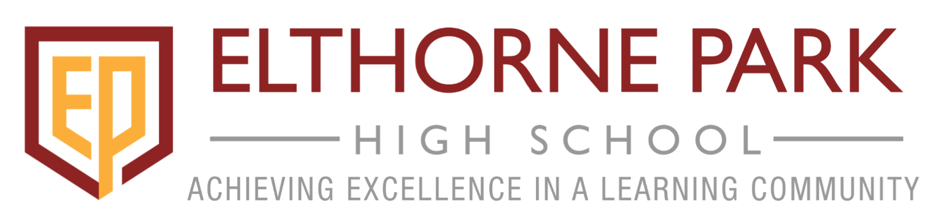

Home and School Partnership Agreement

Achieving Excellence in a Learning Community

Elthorne Park High School is committed to excellence in partnership with the community in order to prepare young people for adult life.

There is a clear link between students’ achievements and the whole hearted commitment of students, parents and staff and therefore it is essential that we form a strong partnership to ensure the success of young people who join this school. To achieve this we all have responsibilities to which we must commit ourselves.

At Elthorne Park High School we are committed to:

- Working towards our vision: ‘achieving excellence in a learning community’, in all activities within the formal curriculum, in extra-curricular activities and through structures and procedures of the school.

- Developing the core values and key attributes in all our students

- Providing the best learning and teaching environment where there is an emphasis on success and where all individuals are valued and all achievements are celebrated.

- Providing a stimulating safe and enjoyable learning environment that recognises the different needs of learners.

- Providing a wide range of learning experiences where individual talent can be developed.

- Listening to and responding to the needs and concerns of students and parents.

- Keeping parents/carers informed and involved in their child’s education with regular progress reviews and reports.

- Setting targets jointly with students to raise achievement.

As a parent/carer, we are/I am committed to:

- Uphold the school values.

- Taking an active part in my child’s school work and ensuring that homework is completed on time.

- Ensuring that my child comes to school in uniform with the necessary equipment.

- Ensuring that my child attends school punctually every day.

- Attending parents’ evenings, responding to letters and reports and keeping the school informed of matters relating to the education, health and welfare of my child.

- Supporting the school and its rules, policies and procedures.

As a student I am committed to:

- Uphold the school values.

- Working to the best of my ability at school and at home.

- Attending school on time, every day, in full uniform and with the necessary equipment.

- Abiding by the school code of conduct and treating all others and the school environment with consideration and respect.

- Taking an active part in the life of the school and community.

- Aiming to improve my previous best in all areas by working to achieve my personal targets (set at school).

We believe that by fulfilling the above we will help to ensure the success and happiness of:

_____________________________________ at Elthorne Park High School

Signed _________________________ Student)

_________________________ (Parent/Carer)

_________________________ (Year Leader/Headteacher)

_________________________ (Date)

