Elthorne Park High School

Safeguarding & Child Protection Policy

Adoption – November 2020
Review frequency - annual
Next review – November 2021
Status – Statutory
Committee – Curriculum

ELTHORNE PARK HIGH SCHOOL CHILD PROTECTION POLICY
KEY CONTACTS WITHIN THE SCHOOL

DESIGNATED SAFEGUARDING LEAD (DSL)
NAME: David White
CONTACT NUMBER: 020 8566 1166 Ex 1030
Location: H block

DEPUTY DESIGNATED SAFEGUARDING LEAD (DDSL)
NAME: Aimee Quinn (KS3 and KS4)
CONTACT NUMBER: 020 8566 1166 Ex 1132
Location: C Block

NAME: Holly Thomas (Sixth Form)
CONTACT NUMBER: 020 8566 1166 Ex 1953
Location: E Block

CHILD PROTECTION ADMINISTRATOR
NAME: Ayesha Arab
CONTACT NUMBER: 020 8566 1166 Ex 1041
Location: SEN department

LAC CO-ORDINATOR Aimee Quinn
CONTACT NUMBER: 020 8566 1166 Ex 1132
Location: SEN department

SCHOOL SUPPORT OFFICER
NAME: Police Constable: Shaq Mughal (SSO)
CONTACT NUMBER: 020 8566 1166 Mobile: 07824 350974
SSO Office: 020 8246 9492

NOMINATED GOVERNOR FOR CHILD PROTECTION
NAME: Matthew Williams
CONTACT NUMBER: 020 8566 1166 Ex 1001 contact via the Head teacher’s PA

KEY CONTACTS WITHIN THE LOCAL AUTHORITY

EALING CHILD PROTECTION ADVICE AND CONSULTATION SERVICE 0208 825 6134

EALING CHILDREN’S INTEGRATED RESPONSE SERVICE 0208 825 8000
Child Protection enquiries, concerns and referrals

EALING LADO – LOCAL AUTHORITY DESIGNATED OFFICER 0208 825 8930
Paul Andrews HYPERLINK "mailto:asv@ealing.gov.uk" asv@ealing.gov.uk

CONTENTS PAGE
Contents | Page Number
Key Contacts Within the School | 2
Contents page | 3-4
1. INTRODUCTION | 5
1.1 Policy Statement | 6
1.2 Terminology | 6
1.3 Purpose and Aims | 7
1.4 Other policies that relate to Safeguarding | 8
2. RECOGNISING ABUSE | 9
2.1 Recognising signs of abuse | 9
2.2 Expert advice and professional organisations | 9
2.3 Types of abuse and neglect | 9
2.4 Indicators of abuse: when to be concerned | 9
2.5 Impact of Abuse | 9
3. CHILD PROTECTION PROCEDURES | 10
3.1 Referral processes | 10-11
Flowchart 1 Actions when there are concerns about a child | 12
3.2 Dealing with a disclosure and making a child protection referral - procedures | 13
Flowchart 2 Reporting a child protection concern | 15
3.3 Confidentiality | 16
3.4 Allegations against a member of staff | 16
3.5 Allegations against students | 17
4. ROLES AND RESPONSIBILITIES | 17
4.1 Responsibilities of all staff | 17
4.2 The Head teacher | 17
4.3 The Designated Safeguarding Lead (DSL) | 17
4.4 The Deputy Designated Safeguarding Lead (DDSL) | 18
4.5 The Child Protection Administrator (CPA) | 19
4.6 Year Leaders, Assistant Year Leaders And Pastoral Support Workers | 19
4.7 The Governing Body | 20
5. SAFEGUARDING & PREVENTION | 21
5.1 Report to Governors | 21
5.2 Training, guidance and support | 21
5.3 Safeguarding and Child Protection Training Schedule | 22
5.4 Supporting a member of staff - disclosure | 22
5.5 Records and Monitoring | 22
5.6 Attendance at child protection conferences & core groups | 23
5.7 Student who is subject to a child protection plan | 23
5.8 Inter-agency liaison | 23
5.9 Children who are subject to court orders | 24
5.10 Self harm – care pathway | 24
5.11 Supporting students at risk | 24
5.12 Good practice guidelines for staff and adults working with students | 24
5.13 Abuse of trust | 25
5.14 Safer recruitment of staff | 25
5.15 Bullying | 26
5.16 E-Safety – online safety | 26
5.17 School watch | 27
5.18 Extended school and off site trips and activities | 27
5.19 Vulnerable Students Looked After Children (LAC) & SEN | 28
5.20 Attendance, registration and site security | 28
6. SPECIFIC SAFEGUARDING ISSUES | 29
6.01 Specific Safeguarding Issues | 29
6.02 Children Missing in Education (CME) | 29
6.03 Female Genital Mutilation (FGM) | 29
6.04 Child Sexual Exploitation (CSE) | 30
6.05 Prevent - Student Radicalisation | 310
6.06 Offensive Weapons Protocol | 29
6.07 Child on Child Sexual Violence and Sexual Harassment | 31
6.08 Sexual Misconduct | 32
6.09 Domestic Abuse | 32
6.10 Mental Health | 32
6.11 Child Sexual Exploitation | 32
6.12 Homelessness | 33
6.13 Forced Marriage | 33
6.14 Honour Based Abuse | 33
6.15 Drugs and County Lines | 33
6.16 Coronavirus Epidemic | 34
7. SCHOOL PREMISES, WISTLEBLOWING, COMPLAINTS AND POLICTY REVIEW | 34
7.01 Use of whole school premises by other organisations | 34
7.02 Whistleblowing | 34
7.03 Making Complaints Against a Member of Staff | 35
7.04 Policy review | 35
APPENDIX | 36
1 Useful contacts | 36
2 Types of Abuse and Neglect | 37
3 Signs and Symptoms of Abuse | 38
4 Child protection referral – initial concerns form | 39-40
5 Body Map | 41
6 Safeguarding and Child Protection: Expert Advice and Professional Organisations | 42
7 Self Harm – Immediate Intervention Flowchart | 43
8 Staff response to an E-Safety incident | 44
9 Staff confirmation of receipt of Safeguarding and Child Protection Policy,  DFE guidance and the Staff Code of Conduct. | 44
10. Flowchart of Disclosure and Barring Service – Criminal record and barred list checks | 46
SAFEGUARDING & CHILD PROTECTION POLICY

- INTRODUCTION

1.1 POLICY STATEMENT
The governors and staff at Elthorne Park High School believe that the highest priority must be given at all times to our statutory duty to safeguard and promote the welfare and safety of our students.

Safeguarding and the protection of students is the responsibility of all members of staff and everyone who comes into contact with our students and their families.
Safeguarding incidents can happen anywhere, staff have a responsibility to report incidents that may have taken place either in or outside of school.
All staff and adults dealing with students should maintain an attitude of ‘it could happen here.’

Section 175 of the Education Act 2002 and ‘Keeping Children Safe’ - DfE 2020 set out statutory
guidance for schools and colleges; placing a statutory responsibility on the governing body to have
policies and procedures in place that safeguard and promote the welfare of children.

This policy has been developed in accordance with the principles established by the Children Act 1989
and includes statutory guidance and recommendations outlined in the following key publications:
- Keeping Children Safe in Education 2020 (DfE)
- Guidance for full openings: schools DfE 1st October 2020
- Coronavirus guidance – Ealing Local Authority 2020. Ealing grid for learning.
- Working Together to Safeguard Children 2015 (DfE)
- Ealing Safeguarding Children Board (ESCB) Guidelines. (2014) LSCB Guidance (Ealing Grid for Learning)
- Pan-London Child Protection Procedures (version 4)
- The Sexual Offences Act 2003
- Data Protection Act 1998
- What to do if you are worried about a child being abused March 2015
- The Prevent Duty - Departmental advice for schools and childcare providers - March 2015 Updated April 2019 (DfE)

1.2 TERMINOLOGY
Safeguarding and promoting the welfare of children is defined as:
- Protecting children from maltreatment;
- Preventing impairment of children’s health or development;
- Ensuring children grow up in circumstances consistent with the provision of safe and effective care;
- Taking action to enable all children to have the best outcomes.
(Working together to Safeguard Children 2015)
School staff form part of the wider safeguarding system for children, this system is described in the statutory guidance Working Together to Safeguard Children 2015 and Keeping Children Safe in Education 2020. The school works closely with social care, the police, health services and other services to safeguard our students.

The Safeguarding and Child Protection Policy form part of a wider portfolio of policies that relate to the safeguarding responsibilities of the school. In particular, this policy should be read in conjunction with the school and local authorities’ Safer recruitment and selection policies, Behaviour policy, Anti bullying policy, Attendance policy, e-Safety policy, Staff code of conduct (staff handbook) Whistle blowing policy and DfE Guidance. These policies are updated annually or in line with statutory change periods agreed by the governing body.

Child protection refers to the processes undertaken to protect children who have been identified as suffering, or being at risk of suffering or significant harm. Where a child is suffering significant harm, or is likely to do so, action should be taken to protect the child. This will involve making an immediate referral to the Deputy Designated Safeguarding Lead so that a social care referral can be made.

Action should also be taken to promote the welfare of a child in need of additional support even if they are not suffering harm or are at immediate risk. This will lead to inter agency processes using local processes.
Staff: refers to those working for on behalf of the school, full time or part time in either paid or voluntary capacity.
Child/Students: refers to all students and children up to the age of 18 or those beyond if still educated at the school. Child and student is used inter changeably in the policy.
Parents: refers to parents and other adults who are in a parenting role including foster carers and adoptive parents.

  - PURPOSE AND AIMS
Our policy applies to all staff, governors and volunteers working in the school.

The five main aims of this policy are to:
- Ensure we practice safe recruitment in checking the suitability of staff and volunteers to work with children
- Raise awareness of child protection issues and equip children with the skills needed to keep them safe
- Develop and implement procedures for identifying and reporting cases, or suspected cases, of abuse
- Support students who have been abused in accordance with the agreed child protection plan
- Establish a safe environment in which children can learn and develop.

This school recognises it is an agent of referral and not of investigation.

We recognise that, because of their day-to-day contact with students, school staff are well placed to observe the outward signs of abuse. The school will therefore:
- Establish and maintain an environment where children feel secure, are encouraged to talk, and are listened to.
- Ensure children know that there are adults in the school whom they can approach if they are worried.
- Include statutory opportunities in the personal, social, health, citizenship and economic programme (PSHCE) and wider curriculum for children to develop the skills they need to recognise and stay safe from abuse.
- Ensure that staff are trained annually and briefed periodically on the latest safeguarding risks to students and actions required to keep children safe.

We follow procedures set out by the Local Safeguarding Children Board (LSCB) and take account of guidance issued by the DfE to ensure that we:
- Have a Designated Safeguarding Lead and a Deputy Designated Safeguarding Leads who have received appropriate training and support for this role
- Have a nominated governor responsible for safeguarding and child protection
- Inform every member of staff (including temporary, supply staff and volunteers) and the governing so that everybody knows the name of the designated senior person responsible for safeguarding and child protection and their role
- Provide guidance for staff and volunteers so they understand their responsibilities in being alert to the signs of abuse and responsibility for referring any concerns to the designated senior person responsible for child protection
- Ensure parents have an understanding of the responsibility placed on the school and staff for child protection by setting out its obligations in the school prospectus
- Notify social services if there is an unexplained absence of more than two days of a student who is on the child protection register
- Develop effective links with relevant agencies and cooperate as required with their enquiries regarding child protection matters, including attendance at case conferences
- Keep written records of concerns about children, even where there is no need to refer the matter immediately
- Ensure all records are kept securely, separate from the main student file, and in locked locations and in secure IT systems.
- Develop and then follow procedures where an allegation is made against a member of staff or volunteer
- Ensure safe recruitment practices are always followed.

We recognise that children who are abused or witness violence may find it difficult to develop a sense of self-worth. The school will endeavour to support the student through:
- The content of the curriculum aimed at keeping children safe;
- The school ethos which promotes a positive, supportive and secure environment and gives students a sense of being valued;
- The school behaviour policy which is aimed at supporting vulnerable students in the school. The school will ensure that the student knows that some behaviour is unacceptable but they are valued and not to be blamed for any abuse which has occurred;
- Liaison with other agencies that support the student such as social services, Supportive Action for Families in Ealing (SAFE), Child and Adult Mental Health Service (CAHMS), counselling and education welfare and educational psychology services;
- Ensuring that, where a student on the child protection register leaves, their information is transferred to the new school immediately and that the child's social worker is informed.

Statement of Intent:
The school is also guided by three important principles outlined in the Children Act 1989:
- the welfare of the child should be paramount
- confidentiality should be respected as far as possible (without compromising the first principle)
- work done with children and families should be open practice

Fundamental to our school’s values and practice is the principle of working with parents, children and outside agencies in partnership to ensure the welfare of all children.

1.4 OTHER POLICIES THAT RELATE TO SAFEGUARDING
This policy should be read by staff in conjunction with the following school policies:
- Anti-bullying
- Allegations of abuse against staff
- Attendance
- Behaviour
- Curriculum and PSHCE policy
- Equality
- E-Safety
- Drugs & RSE
- Health and safety and risk assessments
- Health care plans
- Staff code of conduct
- Staff handbook
- Safer recruitment and selection
- Whistle blowing
- And all other relevant policies that influence student safety and well-being.
The school has adopted and follows LA led safeguarding procedures outlined on the Ealing grid for learning safeguarding: https://www.egfl.org.uk/services-children/safeguarding
- Ealing Child Protection Procedures
- Ealing Child protection and Safeguarding guidance
- Ealing Offensive Weapons in schools protocol
- Staff code of conduct
- Allegations Against Staff and Volunteers
- Coronavirus COVID19 Guidance for Schools https://www.egfl.org.uk/coronavirus

- RECOGNISING ABUSE

2.1 RECOGNISING SIGNS OF ABUSE

To ensure that our students are protected from harm, we need to understand what types of behaviour constitute abuse and neglect.
Abuse and neglect are forms of maltreatment. Somebody may abuse or neglect a child by inflicting harm, for example by hitting them, or by failing to act to prevent harm.

Staff and volunteers should understand that they are not making a diagnosis, only receiving concerns.

None of the signs listed above actually prove that a child is being abused and these indications should not be taken as proof. They may be indicators, which when put into context, provide justification for action.

2.2 EXPERT ADVICE AND PROFESSIONAL ORGANISATIONS
Expert advice and professional organisations are best placed to provide up to date guidance and practical support. For example the NCPCC offer information for schools on the TES website and at www.nspcc.or.uk

Details of expert and professional advice websites can be found in Appendix 7 of this policy.

2.3 TYPES OF ABUSE AND NEGLECT
Abuse: a form of maltreatment of a child. Somebody may abuse or neglect a child by inflicting harm, or by failing to act to prevent harm. They may be abused by an adult or adults or another child or children. The three main forms of abuse are categorised as physical abuse; emotional abuse and sexual abuse.

Neglect: the persistent failure to meet a child’s basic physical and/or psychological needs, likely to result in the serious impairment of the child’s health or development.

Details of the main forms of abuse and neglect are detailed in Appendix 2 and 3 of this policy.
All staff members must familiarise themselves with the signs of abuse and neglect.

2.4 INDICATORS OF ABUSE: WHEN TO BE CONCERNED
Physical signs define some types of abuse, for example, bruising, bleeding, or broken bones resulting from physical or sexual abuse, or injuries sustained while a student has been inadequately supervised.

Staff should be aware of and consider Appendix 3 ‘Signs and Symptoms of Abuse’ these are possible indicators of abuse and neglect that might prompt a child protection concern.

The identification of physical signs is complicated, as students may go to great lengths to hide injuries, often because they are ashamed or embarrassed, or their abuser has threatened further violence or trauma if they ‘tell’. It is also quite difficult for anyone without medical training to categorise injuries into accidental or deliberate with any degree of certainty. For these reasons it is vital that staff are also aware of the range of behavioural indicators of abuse and report any concerns to the Deputy Designated Safeguarding Lead or Safeguarding Lead.

2.5 IMPACT OF ABUSE
The impact of child abuse should not be underestimated. Many students do recover well and go on to lead healthy, happy and productive lives, although most adult survivors agree that the emotional scars remain, however well buried. For some students, full recovery is beyond their reach, and the rest of their childhood and their adulthood may be characterised by anxiety or depression, self-harm, eating disorders, alcohol and substance misuse, unequal and destructive relationships and long-term medical or psychiatric difficulties.

- CHILD PROTECTION PROCEDURES
All staff need to be aware of the signs and symptoms of child abuse, whether physical, emotional, neglect or sexual abuse (see appendix 3)

3.1 REFERRAL PROCESS
Any member of staff, volunteer or visitor to the school who receives a disclosure of abuse, an allegation, or suspects that abuse may have occurred against a child, must report it immediately (at the latest within 24 hours) to the Deputy Designated Safeguarding Leads or, in their absence, the Designated Safeguarding Lead, or the Headteacher (see policy cover sheet for staff contact details).

In their absence, the referral should be brought to the attention of the most senior member of staff in school. Referrals also include situations that may involve a member of staff.
The person referring must record their referral using ‘myconcern’ an electronic referral form. (Appendix 11) When initially recording a referral, staff may use paper to record notes but must then use the electronic referral form on ‘myconcern’ to make a referral (Appendix 4) and a body map (Appendix 5) to detail their referral. A referral has only been made once added to ‘myconcern.’ It is best practice for staff to follow up with a face to face discussion or conversation with the Deputy Safeguarding Lead following a referral.

It is important to note that any member of staff can directly make a referral to children’s social care using the following contact number:
Ealing Children’s Integrated Response Service (ECIRS) Tel: 0208 825 8000
The school asks that when staff make their own referral, information is also shared with the school’s Deputy Designated Safeguarding Lead through completion of an electronic referral form using ‘myconcern.’

If a child’s situation does not appear to be improving, the staff member with concerns should press for further re-consideration.

Once a safeguarding or child protection referral has been received ……
The Deputy Designated Safeguarding Lead will then decide whether to make a referral to social care. (Flowchart 1 ‘Action when a child has suffered or is likely to suffer harm’ (Keeping Children Safe in Education DfE 2020)

The Deputy Designated Safeguarding Lead or their deputy will immediately refer cases of suspected abuse or allegations to the Ealing Integrated Children’s Response Service (ECIRS – see cover sheet)

The telephone referral to ECIRS will be confirmed in writing through completion of the Child and Family Enquiry/Referral form, (located on the school’s system/staff read/child protection documentation) within 24 hours. Essential information will include the student’s name, address, date of birth, family composition, the reason for the referral, whether the student’s parents are aware of the referral, the name of person who initially received the disclosure plus any advice given together with any other information specified on the relevant referral form. This written confirmation must be electronically signed and dated by the referrer.

Parents may or may not be informed depending in the nature of the referral. The school will always undertake to share the intention to refer a student to Social Care Services with parents or carers, unless to do so could place the child at greater risk of harm or impede a criminal investigation. On these occasions advice will be taken from ECIRS or the Metropolitan Police.

Each contact with either student, parent and agencies will be recorded in the child protection referral system – ‘myconcern’ by the Deputy Designated Safeguarding Lead or the Child Protection Administrator.

A copy of the social care referral will be sent to the LBE’s designated officer for child protection. This acts as confirmation of the school’s actions. This is not a substitute for referral to Social Services.

During a student referral……
The Deputy Designated Safeguarding Lead or staff member recording a referral will talk to the student to acknowledge the referral and the address any concerns. The student should be told who knows about the incident and they should be encouraged to approach staff at any time if they wish to discuss any worries. The child must be reassured that they were not to blame for any abuse; they did the right thing in letting others know about it; and that the professionals informed will try to protect them.

The child’s wishes: the school will ensure that the student’s wishes and feelings are taken into account when determining what action to take and what services to provide to support the student but staff members must not promise confidentiality. (section 3.3 Confidentiality)

A copy of the school’s Safeguarding and Child Protection policy is available for parents to access on the school’s website. Parents can obtain a copy of the school child protection policy on request.

Flowchart 1
Actions Where There Are Concerns about a Child
Keeping Children Safe in Education 2020 (page 17)

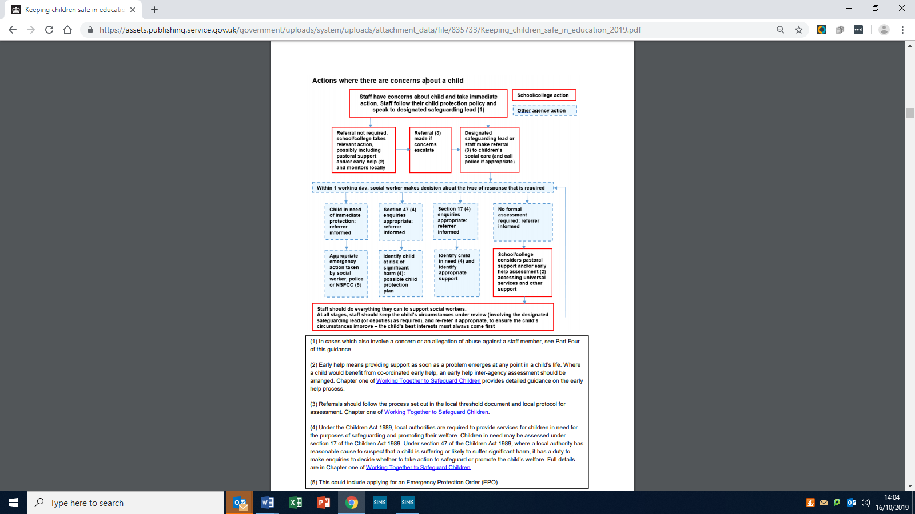

3.2 DEALING WITH A DISCLOSURE & MAKING A CHILD PROTECTION REFERRAL
PROCEDURE

Staff actions – during the disclosure
If a student discloses that they have been abused in some way, the member of staff should:
- Listen to what is being said without displaying shock or disbelief
- Accept what is being said
- Allow the student to talk freely, listen rather than ask direct questions.
- If required, ask open not leading questions
- Reassure the student, but do not make promises which it might not be possible to keep
- Do not promise confidentiality – it will be necessary to refer the matter to the Designated Child Protection Co-ordinator and other support services and agencies.
- Re-assure the student that what has happened is not their fault
- Stress that it was the right thing to talk about it.
- Do not criticise the perpetrator
- Explain what has to be done next and who has to be told.

Please remember that it is not your responsibility as a member of staff to investigate the disclosure.

Record keeping by staff member during and following a disclosure
If a student has disclosed some information which gives rise to concern, the member of staff should:
- Make some brief notes as soon as possible after the conversation
- Record the date, time, place and any noticeable verbal comments and non-verbal actions used by the student.
- Draw a diagram to show the location of any injuries on the Body form. (Appendix 5)
- Complete the Child Protection Referral electronically – Using My Concern (Appendix 4)
- Retain and attach your original notes the ‘Child Protection Referral – Initial concern form’ and ‘Body form.’
- Meet with or communicate with the Deputy Designated Child Protection Lead or Safeguarding Lead(s) following your electronic referral on the day of the disclosure.

Child protection information is stored and handled in line with the Data Protection Act 1998 and will be secure and kept no longer than necessary.

Completed child protection concern referrals must be forwarded immediately or at the latest within 24 hours and forwarded to the Designated Child Protection Co-ordinator.

Anyone can make a child protection referral – you do not have to use the school’s Designated Child Protection Officer.
If a child is in immediate danger of at risk of harm a referral should be made immediately by the member of staff to social care and or the police.
EALING CHILDREN’S INTEGRATED RESPONSE SERVICE : 0208 825 8000

If a member of staff discovers an act of Female Genital Mutilation appears to have been carried out, on a girl under the age of 18, they must report it immediately to the police.

If after a referral the child’s situation does appear to be improving, the Designated Safeguarding Lead, Designated Child Protection Co-ordinator or the person making the referral should press for reconsideration.

If you suspect a student is at risk of harm.
There will be times when you suspect a child may be at risk but have no real evidence. In these circumstances you can provide an opportunity for a child to talk to you. If the student does reveal that they are being harmed or abused then the same steps should be followed as if a disclosure is being made and complete a ‘Child protection referral – initial concerns form.’

Flow chart 2 ‘Reporting a Concern flowchart’ that follows illustrates the process for safeguarding and promoting the welfare of children from the point when concerns are raised about a student.
Flowchart 2
Reporting a Child Protection Concern - Procedural Flowchart

Action taken by the school is taken in line with the following guidance:
- Ealing Safeguarding Children Board (ESCB) Guidelines.
- Safeguarding Children in Education (DfES/0027/2004)
- Pan-London Child Protection Procedures (2020 update)
- Keeping Children Safe in Education (DfE 2020)

WHEN TO CALL THE POLICE?
The designated safeguarding lead and any deputies should liaise with the three safeguarding partners and work with other agencies in line with Working Together to Safeguard Children. NPCC- When to call the police helps designated safeguarding leads understand when they should consider calling the police and what to expect when they do. https://www.npcc.police.uk/documents/Children%20and%20Young%20people/When%20to%20call%20the%20police%20guidance%20for%20schools%20and%20colleges.pdf

3.3 CONFIDENTIALITY
The purpose of confidentiality in this respect is to benefit the student. A member of staff must never guarantee confidentiality to a student nor should they agree with a student to keep a secret when a referral is being made.

Students and their families are entitled to confidentiality but school staff have a duty to pass on confidential information if a student is at risk. Staff will be informed of relevant information in respect of individual cases regarding child protection on a “need to know basis” only. Any information shared with a member of staff in this way must be held confidentially to themselves.

If an allegation of abuse is made against a member of staff, they also have a right to confidentiality.

Child protection files both paper and electronic must be stored where they cannot be read by unauthorised persons. Under the Data Protection Act, parents have a right to see all notes, unless the content could jeopardise a child’s safety.

3.4 ALLEGATIONS AGAINST A MEMBER OF STAFF
It is essential that high standards of concern, confidentiality and professional responsibility are adopted with regard to child abuse allegations made by a student against a member of staff.

Only authorised agencies may investigate child abuse allegations (Social Care Services, the Police or in some areas, the NSPCC). Whilst it is permissible to ask the student simple, non-leading questions to ascertain the facts of the allegation, formal interviews and the taking of statements is not.

The procedure to be followed in the event of an allegation being made against a member of staff is set out in a specific policy. (Allegations of abuse by staff policy)

Matters need to be considered fairly and resolved quickly. There is a duty of confidentiality where a member of staff has an allegation made against them. The duty of confidentiality relates to parents as well as the school, including discussing the matter on social and printed media.

Suspected abuse by a member of staff should be reported immediately to the Designated Safeguarding Lead (not the Head teacher). In their absence, report to the Deputy Designated Safeguarding Lead or the most Senior Member of the Senior Leadership Team.
The Local Authority Designated Officer (LADO) should be informed within one day.

The Designated Safeguarding Lead and Deputy Designated Safeguarding Lead will in the first instance contact the ECIRS. Through discussion and consultation, a decision will be made whether to make a referral to Ealing Social Care Services. The Local Authority Designated Officer (LADO) will be informed within one day. Where the allegation is against the Head teacher, the Chair of Governors will take this action.

If for any reason it is decided that a referral to Ealing social care services is not appropriate, it will be necessary to address matters in accordance with the school’s disciplinary procedures in liaison with the school’s HR Advisor.

The Head teacher will make a referral to the Disclosure and Baring service (DBS) if a person in regulated activity has been dismissed or removed from post due to safeguarding concerns, or would have been had they not resigned. This is a legal duty; failure to refer is a criminal offence.

3.5 ALLEGATIONS AGAINST STUDENTS
A student, against whom an allegation of abuse has been made, may be excluded pending further investigation by the school. In these circumstances procedures outlined in the school’s behaviour policy will be applied. The school will take advice from the Local Authority Designated Officer (LADO) and/or the School’s Safety Officer. All appropriate action will be taken to ensure the safety and welfare of all students involved, including the student or students accused of abuse.

If it is necessary for a student to be interviewed by the police in relation to allegations of abuse, the school will ensure that, subject to the advice of the LADO/SSO, parents are informed as soon as possible and that the student is supported during the interview by an appropriate adult.

- ROLES & RESPONSIBILITIES

4.1 RESPONSIBILITIES OF ALL STAFF
Safeguarding and child protection is the responsibility of all adults and especially those working with children. There are, however, key people within schools and the Local Authority who have specific responsibilities under child protection procedures. The names of those carrying out these responsibilities for the current year are listed on the cover sheet of this policy document.

The development of appropriate procedures and the monitoring of good practice are the responsibilities of the Ealing Safeguarding Children Board (ESCB).

SPECIFIC RESPONSIBILITIES
4. 2 THE HEAD TEACHER
- Ensure that the Safeguarding & Child Protection policy and procedures are implemented and followed by all staff;
- Allocates sufficient time and resources to enable the DSLs and DDSLs to carry out their roles effectively, including the assessment of students and attendance at strategy discussions and other necessary meetings;
- Ensures that all staff feel able to raise concerns about poor or unsafe practice and that such concerns are handled sensitively and if necessary in accordance with the whistle blowing procedures.
- Act on disclosure and barring service cases (cases where a person is dismissed or left due to risk/harm to a student); ensure that the LA and future employers are informed.
- Ensure that all relevant employment checks are carried out on staff (including temporary and voluntary workers) before they have access to students. As part of the schools’ recruitment and vetting process, enhanced Disclosure & Barring Service (DBS), DfE List 99 and other statutory lists and local intelligence checks will be sought on all staff that have substantial and unsupervised access to students.
- Retain a central record if retained of CP training and guidance provided for staff (CP policy/staff code of conduct) provided for staff (including temporary and voluntary workers)

  - THE DESIGNATED SAFEGUARDING LEAD (DSL) AND DEPUTY DESIGNATED SAFEGURADING LEAD CHILD PROTECTION LEAD (DSSL)

Throughout this note, reference to the DSL refers to the designated senior leader for safeguarding and child protection or their deputy.

The ultimate lead responsibility for safeguarding and child protection remains with the designated safeguarding lead. This responsibility should not be delegated.

The DSL must: be appropriately trained at least every two years and have an understanding of LA safeguarding and child protection procedures.

The broad areas of responsibility for the DSL are:
- Ensure each member of staff has access to and understands the school’s safeguarding and child protection policy and procedures, especially new and part time staff
- Ensure that the Ealing LADO procedures are followed by the school
- Managing referrals supported by the Deputy Designated Safeguarding lead.
- Provide guidance advice and support for the DDSL on child protection referrals.
- Communication with the local authority designated officer (LADO) for child protection concerns (all cases which concern a staff member including volunteers);
- Police (cases where a crime may have been committed). Liaise with the Head teacher to inform him of issues especially ongoing enquiries under section 47 of the Children Act 1989 and police investigations
- Raising awareness of Safeguarding concerns and change sot legislation.
- The designated safeguarding lead should ensure that Safeguarding and Child Protection policies are updated, known and used appropriately by staff:
- Ensure the school’s safeguarding and child protection policy is reviewed annually and the procedures and implementation are updated and reviewed regularly, and work with governing bodies or proprietors regarding this
- Ensure the safeguarding and child protection policy is available publicly and parents are aware of the fact that referrals about suspected abuse or neglect may be made and the role of the school in this
- Link with the LA and school’s CPD co-ordinator to make sure staff are aware of training opportunities and the latest local policies on safeguarding. Centralise records of staff attendance at Safeguarding & Child Protection training
- Ensure that the Senior Leadership team are kept fully informed of any problems, difficulties or
concerns;
- Act as a liaison officer for that team and take appropriate action based on the decision(s) made by that team;
- Provide guidance to parents, children and staff about obtaining suitable support;
- Provide support and guidance for the DDSL in relation to cases referred.

In the event of the absence or long-term absence of the Designated Safeguarding Lead (DSL) – the Deputy Safeguarding Lead or Head teacher will assume all of the functions of the DSL.

4.4 THE DEPUTY DESIGNATED SAFEGUARDING LEAD (DDSL)
Throughout this note, reference to the DDSL refers to the Deputy Designated Safeguarding Lead.

The broad areas of responsibility for the designated safeguarding lead are:
Managing referrals
- Refer all cases of suspected abuse to social care (ECIRS Ealing Children’s Integrated Response Service) and the local authority
- Process child protection referrals received by the school
- Share information regarding referrals with the DSL and relevant staff (student forum and line management meetings)
- Lead on the development of Ealing Early Help Assessment Plans (EHAP) for complex multi- agency cases.
- Liaise with the Education Welfare Services and Social Services over suspected cases of child abuse;
- In the case of any specific concern consult with the DSL and convene a case team or conference;
- Submit reports to, and attend Child Protection case conferences or allocate relevant pastoral staff to attend case/review conferences and submit pre meeting reports.
- Keep detailed, accurate, secure written records of concerns and referrals. Ensure that records of concerns relating to individual children are kept in a secure place, separate from the student's main file and marked ‘strictly confidential’ Overview of ‘myconcern’ the school’s electronic child protection database.
- Ensure that children are effectively monitored who have been identified as at risk (via student forum supported by Year Leaders)
- Liaise with social care and professional agencies regarding case reviews, case conferences and professional feedback
- Act as a source of support, advice and expertise to staff on matters on child protection, safety and safeguarding and provide staff members with safeguarding and child protection updates e.g. via email, safeguarding e-bulletins or staff meetings.
- Ensure a student’s child protection file is copied for any new school or college as soon as possible but transferred separately from the main student file when a student leaves the school to join a new educational establishment.

The Deputy Designated Safeguarding lead must also receive appropriate training carried out at least every two years in order to:
- Understand the assessment process for providing early help and intervention, for example through locally agreed common and shared assessment processes such as early help assessments
- Have a working knowledge of how local authorities conduct a child protection case conference and a child protection review conference and be able to attend and contribute to these effectively when required to do so
- Ensure each member of staff has access to and understands the school’s safeguarding and child protection policy and procedures, especially new and part time staff
- Be alert to the specific needs of children in need those with special educational needs and young carers
- Be able to keep detailed, accurate, secure written records of concerns and referrals
- Obtain access to resources and attend any relevant or refresher training courses
- Encourage a culture of listening to children and taking account of their wishes and feelings, among all staff, in any measures the school or college may put in place to protect them.

4.5 CHILD PROTECTION ADMINISTRATOR
- Responsible for the timely update of the school’s child protection records and database (myconcern) including individual student records and files.
- Support with the administration of ECIRs referrals and external agency communication.
- Schedule and organise safeguarding and child protection meetings and diary.
- Lead on all areas of administration in relation to safeguarding and child protection including data overview to support reports to governors.

4.6 YEAR LEADERS, ASSISTANT YEAR LEADERS AND PASTORAL SUPPORT WORKERS
The broad areas of responsibility for Year Leaders, Assistant Year Leaders and Pastoral Support Workers are:
- To record child protection referrals and feedback received about a child from parents and external professionals and share this with DSSL or DSL.
- Keep detailed, accurate, secure written records of concerns and referrals are made using ‘my concern’ and share relevant documents for confidential filing in child protection files.
- To attend as requested by the DSL or DDSL child protection case reviews and conferences and submit progress and information reports to support these meetings.
- Ensure that children are effectively monitored who have been identified as at risk (student forum and line management meetings, case conference and professionals feedback meetings)
- Act as a source of support and advice for member of your team on matters of safety, safeguarding and child protection and identify and support delivery of awareness training delivery.
- Co-ordinate and engage in preventative and supportive interventions to meet students’ needs when at risk of or have child protection concerns i.e. counsellor, parenting programme referrals.
- Support the development of the PSHCE curriculum to meet student’s safeguarding and child protection educational needs and provide information for students as part of the Year group’s SMSC programme
- Allocate and lead (as requested) on referrals to key support agencies such as SAFE (Supportive Action for Families), CAMHS (Children and Adolescent Mental Health Services), Counselling services, Ealing Drugs and Alcohol Team (DAAT), Ealing parenting services, Ealing Young Carers, Ealing Youth and Connexions, EOTAS medical, SSO and relevant voluntary support organisations.
- Contribute to Early Help Assessment Plans (EHAP) forms for students in the Year group and develop and review Care Plans for students with identified SEMH and mental health concerns.
- Ensure a student’s child protection file is copied for any new school or college as soon as possible but transferred separately from the main student file

The school has one Pastoral Support Worker with additional safeguarding duties, trained to support referrals, allocated case conferences and professionals meetings. (Ms Roberts – PSW)

4.7 THE GOVERNING BODY
The Governing body must ensure that they comply with their duties under legislation set out in ‘Keeping Children Safe in Education 2020’ to ensure that the policies, procedures and training in their schools or colleges are effective and comply with the law at all times.

The Governing body must ensure that:
- A DSL for Child Protection is appointed, who is a member of the senior leadership team and who has undertaken training in inter-agency working, in addition to basic Child Protection training, this person will undertake the role of safeguarding lead
- The school contributes to inter-agency working in line with statutory guidance Working Together to Safeguard Children 2013
- Safeguarding arrangements take into account the procedures and practice of the local authority as part of the inter-agency safeguarding procedures set up by the Local Safeguarding Children Board (LSCB)
- Safeguarding arrangements are reviewed annually and the policy made available to parents through the website and upon request
- One of its members is nominated to liaise with the local authority and/or partner agencies on issues of child protection and in the event of allegations of abuse made against the Head teacher, or member of governing body of an independent school
- There is an effective safeguarding and child protection policy in place together with a staff code of conduct, both provided to all staff – including temporary staff and volunteers – on induction. Staff must also be provided with access to section 1 of Keeping Children Safe in Education 2020 when they join the school.
- There is a training strategy in place that ensures all staff, receive annual Child Protection training, with refresher training and specialist training every two years for the DSL and DDSL.
- People who pose a risk of harm are prevented from working with children by adhering to statutory responsibilities to check staff who work with children, taking proportionate decisions on whether to ask for any checks beyond what is required; and ensuring volunteers are appropriately supervised
- There are procedures in place to handle allegations against members of staff, including the Head teacher, and volunteers
- There are procedures in place to handle allegations against other children
- The child’s wishes or feelings are taken into account when determining what action to take and what services to provide to protect individual children through ensuring there are systems in place for children to express their views and give feedback
- Members do not promise confidentiality to the child and always act in the interests of the child
- A designated teacher (DD
- SL) is appointed to promote the educational achievement of children who are looked after and to ensure that this person has appropriate training and that staff have the skills, knowledge and understanding necessary to keeping looked after children safe
- Appropriate safeguarding responses to children who go missing are put in place, particularly on repeat occasions, to help identify any risk of abuse and neglect
Further governor responsibilities:
- A Governor is appointed as Safeguarding and Child Protection Governor (SCPG) who has specific responsibility for Safeguarding and Child Protection.
- At agreed Curriculum Committee Meetings of the Governors, there is a standing agenda item on Child Protection issues including policy review.
- The DSL and DDSL report to Governors termly about child protection incidents and the outcome of the action taken.
- The Safeguarding and Child Protection Policy itself is reviewed annually by the Curriculum Committee of Governors.
- The Chair of the Governing body is nominated as the person responsible for liaising with the local authority and other agencies in the event of an allegation being made against the Head teacher.

- SAFEGUARDING AND PREVENTION

  - REPORT TO THE GOVERNING BODY
The Head teacher’s report to governors will deliver a termly and annual report to governors that outlines:
- Training provided for staff and who delivered it
- Child protection cases reported to social care and resulting actions (anonymised)
- Key support agency referrals
- How staff have been safely recruited
- Safer recruitment training under taken
- Governing body training and audit
- Report from school visits

  - TRAINING, GUIDANCE & SUPPORT
It is important that all staff have training to enable them to recognise possible signs of abuse and neglect and to know what to do if they have a concern.
All staff will be made aware of the process of making referrals to children’s social care and the statutory assessment under the Children’s Act 1989 that may follow a referral, along with the role they might be expected to play in such assessments.
All staff should know what to do if a child tells them they are being abused or neglected and understand the appropriate way to record (not promising confidentiality) and make a referral to the Deputy Designated Safeguarding Lead.
All new staff (teaching/non-teaching) permanent and temporary (including voluntary staff) will receive child protection training by the school before meeting students. Staff training on Safeguarding and Child Protection procedures must be completed annually by all staff. Child protection training at Elthorne Park High school is provided annually and as part of our staff induction process.

All staff will be provided with advice and guidance on the boundaries of appropriate behaviour and conduct. (LA Staff code of conduct) and a copy of the school’s Child Protection Policy and national guidance for schools Keeping Children Safe in Education 2020 (section 1). Staff (permanent and voluntary) will be asked to read and sign that they have read this guidance at the start of each new academic year and when they join the school. Staff will be informed of the names and office locations of the DSL and DDSLs who receive child protection referrals.

In addition, all staff members will receive safeguarding and child protection updates from the DDSL e.g. via email, e-bulletins or staff meetings.

Temporary staff and volunteers who work with students in the school will be made aware of the school’s arrangements for child protection and their responsibilities before meeting with students (DfE 0027/2004).

The school will ensure that the DSL and DDSL undertake training in inter-agency working that is provided by the LA Safeguarding Service, and refresher training at two yearly intervals to keep knowledge and skills up to date.

The Head teacher and all other staff who work with students will undertake appropriate child protection awareness training to equip them to carry out their responsibilities for child protection effectively, that is kept up to date by refresher training at a minimum of three yearly intervals as set out in Safeguarding Children in Education (2020)

Guidance and support is available throughout the year for all staff from the designated child protection officer or designated safeguarding and child protect lead.

Governors with responsibility for Safeguarding and child protection, training and staff appointments will carry out training at a minimum of two yearly intervals.

5.3 SAFEGUARDING AND CHILD PROTECTION TRAINING SCHEDULE
All Staff training  (permanent, temporary and volunteers) | Will be provided annually to all staff and as part of new staff induction training.  On appointment as part of induction training, before the staff member has access to students.  All staff should also receive safeguarding and child protection updates (for example via email, e-bulletins and staff meetings).  Temporary and voluntary staff who work with children are also made aware of the School’s arrangements for safeguarding and their responsibilities as above.
DSL and DDSL | At least every two years  Must attend DSL Safeguarding and CP Training and Prevent training.
Governor and Headteacher training | At regular intervals, at least every three years  Every recruitment panel includes at least one member of staff who has undergone safer recruitment training with refresher training every 5 years.

The school’s CPD co-ordinator and Headteacher’s PA will keep a central record of all safeguarding training undertaken by members of staff.

  - SUPPORTING A MEMBER OF STAFF - DISCLOSURE
Dealing with a disclosure from a child, and being involved in child protection case in general can be a stressful experience. The member of staff should seek support through the DSL, DDSL or the Headteacher.

5.5 RECORDS AND MONITORING
Well-kept records are essential to good child protection practice. Our school is clear about the need to record any concern held about a student or students within our school, the status of such records and when these records should be passed over to other agencies.

Any member of staff receiving a disclosure of abuse or noticing signs or indicators of abuse, must make an accurate record as soon as possible noting what was said or seen, putting the event in context, and giving the date, time and location. All records will be dated and signed and will include the action taken.
Referrals must be completed electronically recorded on ‘myconcern.’ See further guidance in Appendix 4 and 5 of this policy.

Referrals, disclosure notes and child protection records are kept confidentially both electronically and in a confidential file, which is separate to other files, and stored in a secure place in the DDSLs office. In the same way, notes must be kept of any student who is being monitored for child protection reasons. Minutes will be taken at student forum and relevant professionals meetings (DSL and DDSL) to inform child protection records and again recorded and relevant information uploaded onto ‘myconcern.’

If a student transfers from the school, these files will be copied for the new establishment and forwarded to the student’s new school marked confidential and for the attention of the receiving school’s DSL.

5.6 ATTENDANCE AT CHILD PROTECTION CONFERENCES & CORE GROUPS
It is the responsibility of the Deputy Designated Safeguarding Lead to ensure that the school is represented or a report is submitted to any child protection conference called for students on their school roll or previously known to them. Whoever attends will be fully briefed on any issues or concerns the school has and be prepared to make decisions at the conference.

When a child is placed on the Child Protection Register and is, therefore, a child with a plan, it is the Deputy Designated Safeguarding Lead responsibility to ensure that the child is monitored regarding their school attendance, welfare and presentation. The DDSL will be supported by the Year Leader, PSW with safeguarding responsibilities and pastoral team members in this process.

If the school is part of the core group then the Deputy Designated Safeguarding Lead should ensure that the school is represented at core group meetings, and that there is a record of attendance and issues discussed. All concerns about the child protection plan and / or the child’s welfare should be discussed and recorded at the core group meeting unless the child is at further risk of significant harm. In this case the Deputy Designated Safeguarding Lead must inform the child’s key worker immediately and then record that they have done so and the actions agreed.

5.7 STUDENT WHO IS SUBJECT TO A CHILD PROTECTION PLAN
Particular attention will be paid by all teachers to the attendance, welfare, progress and development of any child who has been identified as at risk or who is a “Child who is Subject to a Child Protection Plan”

Staff will be informed on a need to know basis to ensure the student is carefully monitored but also to support student confidentiality.

Student progress will be reviewed by the DDSL and Year Leader at student forum meetings and Child Protection line management meetings.

The student’s Child Protection file will be transferred to receiving schools by the DDSL when a student leaves the school.

5.8 INTER-AGENCY LIAISON
The school follows inter agency procedures set up Ealing’s Local Safeguarding Children Board. An offer of early help when additional needs of children are identified will be provided by the school for external agencies.

Social Care Meetings
At times school staff will be called to participate in meetings and chaired by social care or lead professionals; these might be:
- Strategy discussions (student forum meetings)
- Child protection conference or review conference;
- Professionals meetings i.e. EHAP review meetings

Prior to the meetings, representatives from the school should be ready to report providing information about:
- Attendance and punctuality
- Academic progress
- Parental communication
- Relationships with staff and students
- Student’s appearance, engagement and motivation
- Identification of risk factors
- Any specific incidents that have been reported
- External agency feedback

A chronology of Child Protection intervention, support and communication is confidentially recorded on the school’s centralised Child Protection database – ‘myconcern.’

5.9 CHILDREN WHO ARE THE SUBJECT OF COURT ORDERS
To ensure that students are not collected or have contact with a parent subject to a court order, details of the court order will be confidentially recorded in the school’s central record system (SIMs)
Relevant staff will be informed by the Year Leader and DSL or DDSL when court orders apply.

5.10 SELF HARM - CARE PATHWAY
A disclosure by a student in relation to self-harm is a serious child protection concern and should be reported immediately to the designated child protection co-ordinator. Medical attention should be arranged before the referral is made.

The DDSL will meet with the student to support and reassure the student and will follow guidance outlined in the local authorities’ - ‘Self harm – a short guide for schools’.
Staff who discover a child who has self-harmed in school should follow the guidance in Appendix 7 ‘Self Harm - Immediate help for students.’

The school follows guidance to support for students and families outlined in Ealing’s – Managing Self Harm publication 2014. https://www.egfl.org.uk/sites/default/files/Ealing%27s%20Managing%20Self%20Harm%20Guidance%202014.pdf

5.11 SUPPORTING STUDENTS AT RISK
Our school recognises that students who are abused or who witness violence may find it difficult to develop a sense of self-worth or view the world as a positive place.

This school may be the only stable, secure and predictable element in the lives of a student at risk. Nevertheless, whilst at school their behaviour may still be challenging and defiant or they may appear withdrawn.
This school will endeavour to support students through:
- The curriculum, to encourage self-esteem and self-motivation.
- The school ethos which promotes a positive, supportive and secure environment and which gives all students and adults a sense of being respected and valued.
- The implementation of the school’s behaviour management, anti-bullying and equality policies.
- A consistent approach agreed by all staff which will endeavour to ensure the student knows that some behaviour is unacceptable but s/he is valued.
- Regular liaison with other professionals and agencies who support the students and their families such as CAMHS, SAFE, Counselling services and the Educational Psychology service
- A commitment to develop productive, supportive relationships with parents, whenever it is in the child’s best interest to do so.
- The development and support of a responsive and knowledgeable staff group, trained to respond appropriately in child protection situations.
- Recognition that, statistically, students with behavioural difficulties and disabilities are most vulnerable to abuse, so staff who work in any capacity with students with profound and multiple disabilities, sensory impairment and / or emotional and behavioural problems will need to be particularly sensitive to signs of abuse.
- Recognition that in a home environment where there is domestic violence, drug or alcohol abuse, students may also be vulnerable and in need of support or protection.

  - GOOD PRACTICE GUIDELINES FOR STAFF AND ADULTS WORKING WITH STUDENTS
To meet and maintain our responsibilities towards students we need to agree standards of good practice. Good practice includes:
- Treating all students with respect
- Setting a good example by conducting ourselves appropriately
- Involving students in decisions that affect them
- Encouraging positive and safe behaviour among students
- Being a good listener
- Being alert to changes in students’ behaviour
- Recognising that challenging behaviour may be an indicator of abuse
- Asking the student’s permission before doing anything for them of a physical nature, such as physical support during PE or administering first aid
- Maintaining appropriate standards of conversation and interaction with and between students
- Being aware that the personal and family circumstances and lifestyles of some students lead to an increased risk of abuse.
- Reading, understanding and following our Safeguarding & Child Protection policy, Staff Code of Conduct and ‘Keeping Children Safe in Education’ 2020 (part 1) Appendix 9

5.13 ABUSE OF TRUST
All our staff are aware through the staff code of conduct that inappropriate behaviour towards students is unacceptable and that their conduct towards students must be beyond reproach.
In addition, staff should understand that, under the Sexual Offences Act 2003, it is an offence for a person over the age of 18 to have a sexual relationship with a person under the age of 18, where that person is in a position of trust, even if the relationship is consensual. This means that any sexual activity between a member of the school staff and a student under 18 may be a criminal offence, even if that student is over the age of consent.

The Staff Code of Conduct (Ealing LA code of conduct) sets out our expectations for all staff in relation to appropriate conduct with students.

5.14 SAFER RECRUITMENT OF STAFF
Elthorne Park High School endeavours to ensure that we do our utmost to employ ‘safe’ staff by following the guidance in Keeping Children Safe in Education 2020 together with local authority guidelines on Safer Recruitment and Selection.

All staff responsible for recruitment will engage in safer recruitment training and attend refresher courses if training has exceeded 5 years.

Appointment Panels
At least one member of any appointment panel must have undertaken safer recruitment training.

Safer recruitment means that all applicants will:
- Complete an application form;
- Provide two referees, including at least one who can comment on the applicant’s suitability to work with children;
- Provide evidence of identity and qualifications; (photographic proof)
- Examination of all career breaks in applications as part of the induction process
- Be checked pre-employment: DBS and Barred list checks, Enhanced disclosure & barring list check number, prohibition order checks for teachers, verification of the person’s right to work in the UK, overseas record checks, verification of qualifications, obtaining written references, verification that the person has mental and physical fitness for the role.
- Be interviewed. Staff interviewing panels will include at least one member of staff trained in Safer Recruitment procedures.

There is a legal duty for the school to refer to the Disclosure and Barring Service (DBS) if a person in regulated activity has been dismissed or removed due to safeguarding concerns or would have been had they not resigned.

Employment checks will be carried out for all staff employed by the school.
- Staff employed through agencies we will require confirmation of a DBS check that the individual is eligible to work in the UK. A DBS barred list check will be carried out by the school.
- Supply staff – we will ensure that the agency confirms that all staff used have appropriate DBS checks. Supply agencies must provide written confirmation that all their staff have these checks and have provided staff with the school’s CP policy, Staff code of conduct and National guidance (Keeping Children Safe in Education 2019)
- Volunteers – any volunteer who has regular contact with children (4 times or more in a 30 day period) will have a DBS check if deemed necessary by the Head, but no volunteer who has not been DBS checked will be left unattended with a child.
- Contractors – will not have contact with students unless absolutely necessary in which case all such staff will be subject to appropriate checks. Contractor on site must follow best practice when employing staff they will supply to the school.
- Governors – meeting or having unsupervised contact with students are required to have enhanced criminal record certificate from the DBS. Governors who are volunteers should be treated the same as volunteers.
- Staff or Helpers Supporting an Overnight activity – staff supporting trips who support an overnight activity.
- Contractors who work at the school are subject to DBS checks. Contractors engaging in regulated activity will require an enhanced DBS certificate.
See flowchart – Appendix 10 Flowchart of Disclosure and Barring Service – Criminal record and barred list checks.

Single Central Record
The school will maintain a single, central record for all staff.
All new members of staff will undergo an induction that includes familiarisation with the school’s Safeguarding & Child Protection Policy and Child Protection training.

There should be frequent monitoring by SLT and the direct line managers of newly appointed staff and volunteer workers to ensure students are safe in their care particularly in situations where the school is still waiting to receive the staff member’s DBS certificate.

Under no circumstances should a volunteer or contractor of whom no checks have been obtained be left unsupervised or allowed to work in regulated activity.

It is an offence to permit a staff member carry out any form of regulated activity if they are known to be barred.

All staff must sign a ‘Confirmation of receipt of Safeguarding & Child Protection Policy, Keeping Children Safe in Education 2020 (section 1) and Staff Code of Conduct’ form annually or on arrival at the school to show that they have fully understood the school’s safeguarding and child protection procedures (Appendix 9)

5.15 BULLYING
While bullying between children is not a separate category of abuse and neglect, it is a very serious issue that can cause considerable anxiety and distress. At its most serious level, bullying can lead to students self-harming and suicide.

All incidences of bullying should be reported by members of staff and investigated as per the school’s Anti bullying policy. Bullying incidents must be logged on SIMs and correctly labelled as a bullying incident.

Staff should recognise that students are capable of abusing their peers and it can manifest itself in many different ways e.g. online bullying, sexting, inappropriate sexual touching etc.

PEER ON PEER ABUSE
Bullying themes are addressed at regular intervals by the personal, social, health and citizenship education programme (PSHCE), assemblies, tutor time, and as themes across the curriculum.

If bullying is particularly serious, or the anti-bullying procedures are deemed to be ineffective, child protection procedures referral procedures should be followed. The school’s Anti-Bullying policy is available for parents on the school’s website.

5.16 eSAFETY: ONLINE SAFETY
As a school we are increasingly aware of the growing risks to children working online. The school provides protection for students in a number of ways; procedures are outlined in the school’s eSafety and anti-bullying policies. If a child is deemed to be at risk a child protection referral should be made to the DDSL or DSL.

The school delivers a comprehensive curriculum programme for students around online safety (Computing lessons, PSHCE lessons and assemblies) & related safeguarding issues, so that all students are aware of the risks and know what to do if they experience a problem online.
The school uses many of the suggested activities and approaches outlined in the non-statutory guidance for schools Teaching Online Safety in Schools (DfE 2019) to ensure our students are informed and remain safe when using online technology.

The school uses a commercial monitoring and filtering systems provided by (Smoothwall & Impero) to identify inappropriate use if IT and internet systems by students or staff, this report is actioned on a weekly basis by the DSL.

It is important that all students observe and follow the ICT appropriate use agreement. Staff must read, observe and follow this agreement and guidance outlined in the school’s e-Safety policy and the Staff Code of Conduct relating to safe use of technology and appropriate communication.

Most students use mobile ‘phones (students advised not to bring these to school) and computers to support their studies and to communicate with other people. They can be a source of fun, entertainment, communication and education. However, we know that some men, women and young people will use these technologies to harm children.

Chat-rooms and social networking sites are the more obvious sources of inappropriate and harmful behaviour and students are not allowed to access these sites in school. The harm might range from sending hurtful or abusive texts and emails, to enticing children to engage in sexually harmful conversations, webcam photography or face-to-face meetings. The school’s e-Safety Policy explains how we try to keep students safe in school.

Cyber-bullying by students via texts and emails, will be treated as seriously as any other type of bullying and will be managed through our behaviour and anti-bullying procedures. Staff are required to follow guidance in flowchart (Appendix 8) ‘Staff response to an e-Safety incident if an e-Safety incident takes place where a child is at risk.

5.17 COMMUNITY INCIDENTS - SCHOOL WATCH
Separate arrangements exist where children may be at risk from strangers who have approached other children in the neighbourhood or who have been seen acting suspiciously in other parts of Ealing. Through the School Watch system, run by the Metropolitan Police in conjunction with the Education Welfare Service and institutions themselves, information is passed rapidly from school to school so that warnings can be given to teachers, parents and students as appropriate. The DSL and DDSL are the school leads for this arrangement and will inform staff and the school’s safety officer, should risks to students and staff arise.

5.18 EXTENDED SCHOOL AND OFF-SITE TRIPS AND ACTIVITIES
Where trips and extended school activities are provided by and managed by the school, our own Safeguarding & Child Protection policy and procedures apply.

If other organisations provide services or activities on our site we will check that they have appropriate procedures in place, including safer recruitment procedures.
When our students attend off-site activities, we will check that effective Child Protection and risk assessment arrangements are in place in line with the school’s Trips and Visits policy and guidance outlined in Keeping Children Safe in Education Guidance 2020.

There is specific guidance that trip organisers must follow if students are staying with host families. Staff arranging the visit must follow guidance outlined in Annexe E in ‘Children staying with host families’ in Keeping Children Safe in Education 2020. Trip leaders must ensure this has been followed, details in the School’s Trips Policy.

5.19 VULNERABLE GROUPS OF STUDENTS
LOOKED AFTER CHILDREN (LAC) and children with SPECIAL EDUCATIONAL NEEDS
Staff need to be aware that specific groups of students may be at greater risk of abuse or neglect.
- Looked after Children (LAC)
- Special Educational Needs and disabilities
The school’s LAC co-ordinator is our Assistant Headteacher - Ms Quinn, she will provide staff with information on LAC students and how we can best support their needs and keep them safe. Ms Reeves is the school’s Special Educational Needs Co-ordinator.

LOOKED AFTER CHILDREN
The most common reason for children becoming looked after is as a result of abuse and or neglect.
We have a Designated Lead responsible for Looked After Children, (Ms Quinn) and a governor with overall responsibility. The school keeps a central record of students who are looked after by the local authority.
In light of research that shows that LACs are more vulnerable to abuse and fare less well at schools than their peers, close monitoring of their progress and wellbeing will take place by the LAC co-ordinator:
- Attending any liaison or review meetings held on their behalf, including speaking for them or acting as their advocate at such meetings should they request it, and keeping in touch with social workers and/or carers
- Monitoring their attendance carefully and reporting any unexplained absence to social care and the Educational Welfare service
- Monitoring their academic grades carefully to try to ensure they are making expected progress
- Liaising with their tutor and subject staff to ensure they are safe and making expected progress
- Knowing the exact legal status of each looked after child in school
- Recording contact arrangements with birth parents or those with parental responsibility
- Knowing the child’s care arrangements and the levels of authority delegated to the carer by the authority looking after him/her.
- Having details of the child’s social worker and the name of the virtual school head in the authority that looks after the child.

Children with Special Educational Needs & Disabilities
Staff need to aware that children with SEN and disabilities can face additional safeguarding challenges and may be more prone to bullying and other forms of abuse.

5.20 ATTENDANCE, REGISTRATION, VISITORS AND SITE SECURITY
Attendance Registers
It is a statutory duty for staff to register students at am and pm registration. Staff must also register students in their classes during the first ten minutes of each lesson. This enables the school to quickly identify any students missing from lessons.
If a child is suspected missing the staff member must inform the main office immediately so a search of the site and CCTV can be carried out by staff on ‘call out’, the Attendance Officer and the School’s Safety Officer. If a student is missing, parents will be informed immediately following the school’s search.

Visitors and Site Security

With the exception of sixth formers, students are not permitted to leave the school site during the school day. Signed parental permission is required on entry to the school for students to be permitted supervised use of the playing fields and MUGA at lunchtime; permission is recorded on student ID cards.

All staff and students must wear their ID badges at all times when on school site.

Visitors must sign in at reception on arrival and will be issued with a temporary ID badge. CCTV cameras are used in buildings and across the school site to support site security.

Should a member of the public try to illegally enter the school site, the School’s Safety Officer, DDSL or DSL must be informed immediately and following assessment of the situation the police may be called.
- SPECIFIC SAFEGUARDING CONCERNS

6.01 SPECIFIC SAFEGUARDING ISSUES
All staff should have an awareness of the following safeguarding issues:
Bullying including cyber bullying  Children missing education  Children missing from home or care  Child sexual exploitation  Domestic violence  Drugs  Fabricated or induced illness  Faith abuse  Female genital mutilation (FGM)  Forced marriage  Gangs and youth violence | Gender based violence/violence against women and girls. (VAWG)  Honour Based Violence  Hate  Mental health  Missing children and adults  Private fostering  Preventing radicalisation  Relationship abuse  Sexting  Trafficking
Staff should be aware that behaviour linked to drug taking, alcohol abuse, truanting and sexting put children in real danger.
Appendix 6 provides further guidance and information in relation to these safeguarding themes.

6.02 CHILDREN MISSING IN EDUCATION
A child missing education is a potential indicator of neglect.
Any child absent from school will be subject to procedures outlined in the school’s Attendance Policy and eventually intervention by the school’s Attendance Officer.

If a child is absent from school for a significant period of time (10 sessions) or on repeat occasions without communication from parents, the school will report the child to the local authority as a child ‘missing in education.’

This report will initiate further investigation by the local authority CME safeguarding team and police to locate the student and family. See procedures outlined in the school’s Attendance Policy.
The school provides regular returns to the local authority on children missing education and reasonable enquiries made by the school. The school provides weekly returns of admissions and new arrivals to the school.

6.03 FEMALE GENITAL MUTILATION
FGM involves cutting and sometimes sewing of the girl’s genetalia, normally without anaesthetic, and can take place at any time from birth onwards. It is sometimes referred to as ‘female circumcision.’ It is now more correctly termed female genital mutilation (FGM).

The procedure has a cultural, rather than religious, origin and is practiced by disparate ethnic communities including Ethiopia, Somalia, Sudan, Egypt, Nigeria, India, Pakistan Yemen and Iraq.
The Female Genital Mutilation Act 2003 makes it an offence, not only to carry out FGM in the UK but also to take a girl out of the UK to have FGM performed abroad, even in countries where it is legal.

The indicators of FGM initially mirror those of sexual abuse. You may notice the girl or young woman shows:
- Signs of pain and discomfort
- Needs to visit the toilet constantly (possible vaginal blood loss)
- Unable to sit comfortably
- Make excuses to avoid showers in PE
- May be evasive or fearful following enquiries
- Seems to be in pain but has not visited her family doctor
- There may be a pattern of absence from school or late to return after the school holiday (possible regions of FGM practice listed above)

Any concerns or suspicions should be reported to the as an initial concern.

6.04 CHILD SEXUAL EXPLOITATION (CSE)
CSE involves students receiving something in exchange for sexual acts. Sexual exploitation can take many forms ranging from seemingly consensual relationships to serious gang and group exploitation. Staff should be aware that sexual exploitation can take many forms and that students may not exhibit external signs of abuse. Therefore, staff must be vigilant for the less obvious signs i.e. lots of new electronic equipment, when before there was none, seeming to have extra money to spend, moving away from established friendship groups.

The Deputy Designated Safeguarding Lead or Designated Safeguarding Lead will undertake child exploitation training as part of their training cycle.

6.05 PREVENT - STUDENT RADICALISATION
If the school suspects a student is at risk of radicalisation or their associated actions may place them or others at risk, the school will act in accordance with statutory DfE guidance - The Prevent Duty - Departmental advice for schools and childcare providers.’ (DfE: June 2015 The Prevent Duty for Schools)

If a member of staff has a concern about a particular student they must follow the school’s normal safeguarding procedures, including discussing their concerns with the school’s designated safeguarding lead, and where deemed necessary, with children’s social worker.

The school will inform the Local Authority Prevent lead who can also provide support. The school may also contact the local police force or dial 101 (the non-emergency number) for further guidance.

LA PREVENT Contacts

General enquiries
Email: preventschoolsinfo@ealing.gov.uk(link sends e-mail)
Nazia Matin
Prevent co-ordinator
Email: matinn@ealing.gov.uk(link sends e-mail)
Tel: 020 8825 8895
Sonita Pobi-Busigu
Prevent education officer - curriculum guidance and training
Email: PobiBusiguS@ealing.gov.uk(link sends e-mail)
Tel: 020 8825 6476
Paul Smith
Prevent safeguarding manager – all issues related to CHANNEL case management
Email: smithpa@ealing.gov.uk(link sends e-mail)
Tel: 020 8825 7590

The Department for Education has dedicated a telephone helpline (020 7340 7264) to enable staff and governors to raise concerns relating to extremism directly. Concerns can also be raised by email to counter.extremism@education.gsi.gov.uk. The helpline is not intended for use in emergency situations, such as a child being at immediate risk of harm or a security incident.

6.06 OFFENSIVE WEAPONS IN SCHOOL PROTOCOL

The school adheres to guidance set out in the Local Authority ‘Offensive Weapons in School’s Protocol.’ (2020 – Ealing Grid for Learning/Safeguarding)

This states actions that the school will take in relation to offensive weapon possession by a member of the school community.
The guidance states:
- Definition of an offensive weapon
- Staff powers
- Guidance of searches
- Procures to be followed when an offensive weapon is discovered & subsequent actions.
- Police actions
- Non arrest decisions by the school.

Actions are followed in association with guidance outlined in the school’s behaviour policy.

If an offensive weapon is found on school site staff must:
- Make an immediate call out for SLT support.
- Parents are informed.
- Appropriate action is taken to search and confiscate the offensive weapon.
- The school will inform the police and the School’s Safety Officer.
- The Designated Safeguarding Lead is informed.

Subsequent actions in relation to whole school will be actioned after a full investigation by the school.

6.07 CHILD ON CHILD SEXUAL VIOLENCE & SEXUAL HARASSMENT.
.
If possible two members of staff will be present when recording incidents. Inform the designated safeguarding lead or designated child protection officer a deputy immediately.

The starting point regarding any report should always be that sexual violence and sexual harassment is not acceptable and will not be tolerated. Especially important is not to pass off any sexual violence or sexual harassment as ‘banter’, ‘part of growing up’ or ‘having a laugh’.

Where the report includes an online element, being aware of searching screening and confiscation advice (for schools) and UKCCIS sexting advice (for schools and colleges). The key consideration is for staff not to view or forward illegal images of a child. The highlighted advice provides more details on what to do when viewing an image is unavoidable.

Sexual violence and sexual harassment can occur between two children of any age and sex. It can also occur through a group of children sexually assaulting or sexually harassing a single child or group of children. Children who are victims of sexual violence and sexual harassment will likely find the experience stressful and distressing. This will, in all likelihood, adversely affect their educational attainment. Sexual violence and sexual harassment exist on a continuum and may overlap, they can occur online and offline (both physical and verbal) and are never acceptable. It is important that all victims are taken seriously and offered appropriate support. Staff should be aware that some groups are potentially more at risk. Evidence shows girls, children with SEND and LGBT children are at greater risk.

What is sexual violence and sexual harassment?
Sexual violence
When referring to sexual violence we are referring to sexual violence offences under the Sexual Offences Act 2003111 as described below and includes, rape, assault by penetration and sexual assault.

Sexual harassment
When referring to sexual harassment we mean ‘unwanted conduct of a sexual nature’ that can occur online and offline.

Sexual harassment is likely to: violate a child’s dignity, and/or make them feel intimidated, degraded or humiliated and/or create a hostile, offensive or sexualised environment.

Whilst not intended to be an exhaustive list, sexual harassment can include:
• sexual comments, such as: telling sexual stories, making lewd comments, making sexual remarks about clothes and appearance and calling someone sexualised names;
• sexual “jokes” or taunting;
• physical behaviour, such as: deliberately brushing against someone, interfering with someone’s clothes (schools and colleges should be considering when any of this crosses a line into sexual violence - it is important to talk to and consider the experience of the victim) and displaying pictures, photos or drawings of a sexual nature; and
• online sexual harassment. This may be standalone, or part of a wider pattern of sexual harassment and/or sexual violence.
• non-consensual sharing of sexual images and videos;
• sexualised online bullying;

6.08 SEXUAL MISCONDUCT – Upskirting
‘Upskirting’ typically involves taking a picture under a person’s clothing without them knowing, with the intention of viewing their genitals or buttocks to obtain sexual gratification, or cause the victim humiliation, distress or alarm. It is now a criminal offence.

Any cases reported must be actioned as follows:
Member of staff immediately reports the incident to the Deputy Designated Safeguarding Lead or Safeguarding lead and the student’s Year Leader. The parents of the perpetrator will be informed.
The police will be informed and our attached School Safety Officer. A full investigation will be completed by the school. Actions taken in line with whole school behaviour policy following investigation.

6.09 DOMESTIC ABUSE
Children can witness and be adversely affected by domestic abuse and/or violence at home where it occurs between family members. In some cases, a child may blame themselves for the abuse or may have had to leave the family home as a result. Older children may also experience domestic abuse and/or violence in their own personal relationships. Exposure to domestic abuse and/or violence can have a serious, long-lasting emotional and psychological impact on children.

Operation Encompass – Elthorne Park High school works in partnership with the Metropolitan Police and Children’s Services to identify and provide appropriate support to pupils who have experienced domestic incidents; this scheme is called Operation Encompass. The purpose of Operation Encompass is to safeguard and support children and young people who have been involved in, or witness to a domestic incident.

6.10 MENTAL HEALTH

All staff should also be aware that mental health problems can, in some cases, be an indicator that a child has suffered or is at risk of suffering abuse, neglect or exploitation.

Only appropriately trained professionals should attempt to make a diagnosis of a mental health problem. Staff however, are well placed to observe children day-to-day and identify those whose behaviour suggests that they may be experiencing a mental health problem or be at risk of developing one.

Where children have suffered abuse and neglect, or other potentially traumatic adverse childhood experiences, this can have a lasting impact throughout childhood, adolescence and into adulthood. It is key that staff are aware of how these children’s experiences, can impact on their mental health, behaviour and education.

If staff have a mental health concern about a child that is also a safeguarding concern, immediate action should be taken, following their child protection policy and speaking to the designated safeguarding lead or a deputy.

6.11 CHILD CRIMINAL EXPLOITATION (CCE)
This abuse takes place when an individual or group takes advantage of an imbalance of power to coerce, control, manipulate or deceive a child into criminal activity. Thus may be in exchange for something the victim needs or wants, and/or for the financial or other advantage of the perpetrator or facilitator, and/or through violence or the threat of violence.

The abuse can be perpetrated by males or females, and children or adults. It can be a one-off occurrence or a series of incidents over time, and range from opportunistic to complex organised abuse. The victim can be exploited even when the activity appears to be consensual It does not always involve physical contact and can happen online.

If a member of staff suspects CCE, they will discuss this with the DSL. The DSL will trigger the local safeguarding procedures, including a referral to the local authority’s children’s social care team and the police, if appropriate.

6.12 HOMELESSNESS
Being homeless or being at risk of becoming homeless presents a real risk to a child’s welfare. The DSL deputies will be aware of contact details and referral routes in to the local housing authority so they can raise/progress concerns at the earliest opportunity as appropriate. Where a child has been harmed or is at risk of harm, the DSL will also make a referral to children’s social care.

6.13 FORCED MARRIAGE
Forcing a person into marriage is a crime. A forced marriage is one entered into without the full and free consent of one or both parties and where violence, threats, or any other form of coercion is used to cause a person to enter into a marriage. Threats can be physical or emotional and psychological.
If a member of staff they must report this to the DSL who will speak to the pupil about the concerns in a secure and private place and activate the local safeguarding procedures and refer the case to the local authority’s designated officer and seek advice from the Forced Marriage Unit on 020 7008 0151 or fmu@fco.gov.uk

6.14 HONOUR BASED ABUSE
So called honour-based’ abuse (HBA) encompasses incidents or crimes committed to protect or defend the honour of the family and/or community, including FGM, forced marriage, and practices such as breast ironing.

Abuse committed in this context often involves a wider network of family or community pressure and can include multiple perpetrators. All forms of HBA are abuse and will be handled and escalated as such. If staff have a concern, they will speak to the DSL, who will activate local safeguarding procedures.

6.15 DRUGS AND COUNTY LINES
Student use of drugs and alcohol can place them at risk of harm. It is important that any reports of students using or holding illegal drugs is reported immediately to the DSL or DDSL. Following a report protocols outlined in the school’s behaviour policy and DfE and ACPO guidance will be followed https://assets.publishing.service.gov.uk/government/uploads/system/uploads/attachment_data/file/270169/drug_advice_for_schools.pdf.

6.16 COUNTY LINES
This term is used to describe gangs and organised criminal networks involved in exporting illegal drugs into one or more importing areas.

Exploitation is an integral part of the county lines offending model with children and vulnerable adults exploited to move [and store] drugs and money. Offenders will often use coercion, intimidation, violence (including sexual violence) and weapons to ensure compliance of victims.

Children can be targeted and recruited into county lines in a number of locations including schools, further and higher educational institutions, pupil referral units, special educational needs schools, children’s homes and care homes. Children are often recruited to move drugs and money between locations.

6.17 CORONAVIRUS PANDEMIC
The coronavirus pandemic is a significant health risk to all members of the school and local community. To minimise risk, the school has completed a COVID19 risk assessment and developed related procedures based around the government’s 10 prevention control measures. The school also follows local authority guidance in relation to COVID19 guidance and procedures.

It is important that all students, parents and staff are familiar with and follow the following COVID19 guidance and procedures:
COVID19 school risk assessment  Elthorne Park High School | https://www.ephs.ealing.sch.uk/uploads/7/4/6/2/74626919/parent_copy_of_risk_assessment_-_for_september_2020.pdf
Guidance for students and parents – COVID19 school procedures and FAQs | https://www.ephs.ealing.sch.uk/uploads/7/4/6/2/74626919/covid-19_guidance_for_parents.pdf
COVID 19 – School Procedures to minimise risk from COVID19 | https://www.ephs.ealing.sch.uk/uploads/7/4/6/2/74626919/student_guidance_-_re-opening_september_2020.pdf
LA Guidance for parents  What do if someone has COVID19 symptoms | https://www.ephs.ealing.sch.uk/uploads/7/4/6/2/74626919/flowchart_for_parents_-_when_your_child_should_attend_school_30_july_2020.pdf
NHS Guidance  Symptoms and Contacts | https://www.ephs.ealing.sch.uk/uploads/7/4/6/2/74626919/clch_covid-19_symptom_or_contact_guide_for_schools_16_september_2020.pdf
Protective Face Masks – COVID19  School Procedures. | https://www.ephs.ealing.sch.uk/uploads/7/4/6/2/74626919/face_masks_guidance_nov_2020.pptx_1.pdf
When you should book a coronavirus test for your child? DfE 2020 | https://www.gov.uk/government/publications/guidance-to-parents-and-guardians-when-you-should-book-a-coronavirus-test-for-your-child/letter-to-parents-and-guardians-when-you-should-book-a-coronavirus-test-for-your-child
This guidance can be accessed on the school’s website and is regularly updated following local and national policy changes.

SCHOOL PREMISES, WISTLEBLOWING, COMPLAINTS AND POLICTY REVIEW

  - USE OF SCHOOL PREMISES BY OTHER ORGANISATIONS
Where services or activities are provided separately by another body using the school premises, the Governing Body will seek assurance that the body concerned has appropriate policies and procedures in place in regard to safeguarding students and child protection.

7.02 WHISTLEBLOWING
All staff and volunteers should feel able to raise concerns about poor or unsafe practice and
potential failures in the school’s safeguarding regime. Concerns should be reported immediately to the
Headteacher, a member of the Senior Leadership Team or the Governing Body.

All staff should also be aware of their duty to raise concerns about the attitude or actions of colleagues if they witness or suspect abuse or inappropriate handling of cases. If necessary, they should speak to the nominated ‘whistleblowing’ governor or the Education Safeguarding Service on 020 8825 8364.

7.03 MAKING COMPLAINTS AGAINST A MEMBER OF STAFF
If a member of staff, parent or student has a complaint regarding a member of staff, they should use and follow the school’s Complaint procedures, a copy of this procedure if available on the school website. Procedures to deal with allegations against teachers, headteachers, volunteers and other staff are outlined in this policy.

Such allegations will be referred to the designated officers (LADO) at the local authority for investigation.

7.04 POLICY REVIEW
The Governing Body is responsible for ensuring annual review of this policy. As part of the review process staff and staff representatives (Staff Governors) will be asked to contribute to and shape Child Protection and Safeguarding procedures.

Date when current policy was reviewed and adopted by Governors. | November 2020
Next review date: | November 2021
Appendix 1

USEFUL CONTACTS

Ealing Children’s Integrated Response Service

EALING CHILD PROTECTION ADVICE AND CONSULTATION SERVICE 0208 825 6134

EALING CHILDREN’S INTEGRATED RESPONSE SERVICE 0208 825 8000
Child Protection enquiries, concerns and referrals

EALING LADO – LOCAL AUTHORITY DESIGNATED OFFICER 0208 825 8930
Paul Andrews asv@ealing.gov.uk

Ealing Social Services Offices

Acton Children’s Services
Acton Town Hall Winchester Street
London
W3 6NE
FAX: 0208 993 2606
T: 0208 8000

Greenford Children’s Services
301 Ruislip Road
Greenford
UB6 9SE
FAX: 0208 578 2654
T: 0208 8000

Ealing Police Station Tel: 101

CAMHS – West London Tel: 020 8354 8160

NSPCC Tel: 0808 9005000

Childline: Tel: 0800 1111
Prevent Ealing Tel: 020 8825 9849

Appendix 2
TYPES OF ABUSE AND NEGLECT

Abuse: a form of maltreatment of a child. Somebody may abuse or neglect a child by inflicting harm, or by failing to act to prevent harm. They may be abused by an adult or adults or another child or children.

Physical abuse: a form of abuse which may involve hitting, shaking, throwing, poisoning, burning or scalding, drowning, suffocating or otherwise causing physical harm to a child. Physical harm may also be caused when a parent or carer fabricates the symptoms of, or deliberately induces, illness in a child.

Emotional abuse: the persistent emotional maltreatment of a child such as to cause severe and adverse effects on the child’s emotional development. It may involve conveying to a child that they are worthless or unloved, inadequate, or valued only insofar as they meet the needs of another person. It may include not giving the child opportunities to express their views, deliberately silencing them or ‘making fun’ of what they say or how they communicate. It may feature age or developmentally inappropriate expectations being imposed on children. These may include interactions that are beyond a child’s developmental capability as well as overprotection and limitation of exploration and learning, or preventing the child participating in normal social interaction. It may involve seeing or hearing the ill-treatment of another. It may involve serious bullying (including cyberbullying), causing children frequently to feel frightened or in danger, or the exploitation or corruption of children. Some level of emotional abuse is involved in all types of maltreatment of a child, although it may occur alone.

Sexual abuse: involves forcing or enticing a child or young person to take part in sexual activities, not necessarily involving a high level of violence, whether or not the child is aware of what is happening. The activities may involve physical contact, including assault by penetration (for example rape or oral sex) or non-penetrative acts such as masturbation, kissing, rubbing and touching outside of clothing. They may also include non-contact activities, such as involving children in looking at, or in the production of, sexual images, watching sexual activities, encouraging children to behave in sexually inappropriate ways, or grooming a child in preparation for abuse (including via the internet). Sexual abuse is not solely perpetrated by adult males. Women can also commit acts of sexual abuse, as can other children.
Neglect: the persistent failure to meet a child’s basic physical and/or psychological needs, likely to result in the serious impairment of the child’s health or development. Neglect may occur during pregnancy as a result of maternal substance abuse. Once a child is born, neglect may involve a parent or carer failing to: provide adequate food, clothing and shelter (including exclusion from home or abandonment); protect a child from physical and emotional harm or danger; ensure adequate supervision (including the use of inadequate care-givers); or ensure access to appropriate medical care or treatment. It may also include neglect of, or unresponsiveness to, a child’s basic emotional needs.

‘Keeping Children Safe in Education 2020’ (DfE)

Appendix 3
SIGNS AND SYMPTOMS OF ABUSE

Possible signs of physical abuse:
- Unexplained injuries or burns, particularly if they are recurrent
- Refusal to discuss injuries
- Improbable explanations for injuries
- Untreated injuries or lingering illness not attended to
- Admission of punishment which seems excessive
- Shrinking from physical contact
- Fear of returning home or of parents being contacted
- Fear of undressing
- Fear of medical help
- Aggression/bullying
- Over compliant behaviour or a ‘watchful’ attitude
- Running away
- Significant changes in behaviour without explanation
- Deterioration in work
- Unexplained pattern of absences which may serve to hide bruises or other physical injuries

Possible signs of emotional abuse:
- Continual self-deprecation
- Fear of new situations
- Inappropriate emotional responses to painful situations
- Self-harm or mutilation
- Compulsive stealing/scrounging
- Drug/solvent abuse
- ‘Neurotic’ behaviour – obsessive rocking, thumb-sucking and so on
- Air of detachment – ‘don’t care’ attitude
- Social isolation – does not join in and has few friends
- Desperate attention-seeking behaviour
- Eating problems, including overeating and lack of appetite
- Depression, withdrawal

Possible signs of neglect:
- Constant hunger
- Poor personal hygiene
- Inappropriate clothing
- Frequent lateness or non-attendance at school
- Untreated medical problems
- Low self-esteem
- Poor social relationships
- Compulsive stealing or scrounging
- Constant tiredness

Possible signs of sexual abuse:
- Bruises, scratches, burns or bite marks on the body
- Scratches, abrasions or persistent infections in the anal or genital regions
- Pregnancy – particularly in the case of young adolescents who are evasive concerning the identity of the father
- Sexual awareness inappropriate to the child’s age – shown e.g. in drawings, vocabulary, games and so on
- Frequent public masturbation
- Attempts to teach other children about sexual activity
- Refusing to stay with certain people or go to certain places
- Aggressiveness, anger, anxiety, tearfulness
- Withdrawal from friends

Appendix 4
Child Protection Referral - ‘myconcern’ electronic referral form

If you are approached by a child or parent and are concerned that it may be a Safeguarding or Child Protection issue, please complete an electronic referral to the Deputy Designated Safeguarding Lead or Designated Safeguarding Lead using ‘myconcern.’

Complete the electronic form using ‘myconcern’ immediately after you receive a referral or if you have concerns about a child’s safety or welfare.

Please record statements and observations rather than interpretations or assumptions.

Please attach or sketch and upload a ‘body map’ form indicating injuries if relevant.

Please attach any additional notes that you may have made during the initial disclosure.
Complete all sections of the ‘myconcern’ referral form.

Follow up with a face to face meeting or communication with the Deputy Designated Safeguarding Lead or Safeguarding Lead after your referral on the same day of the referral.

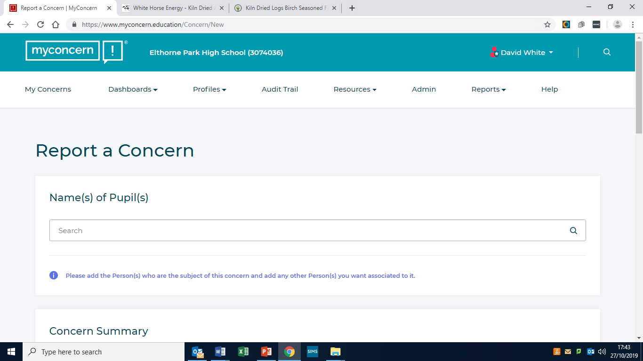

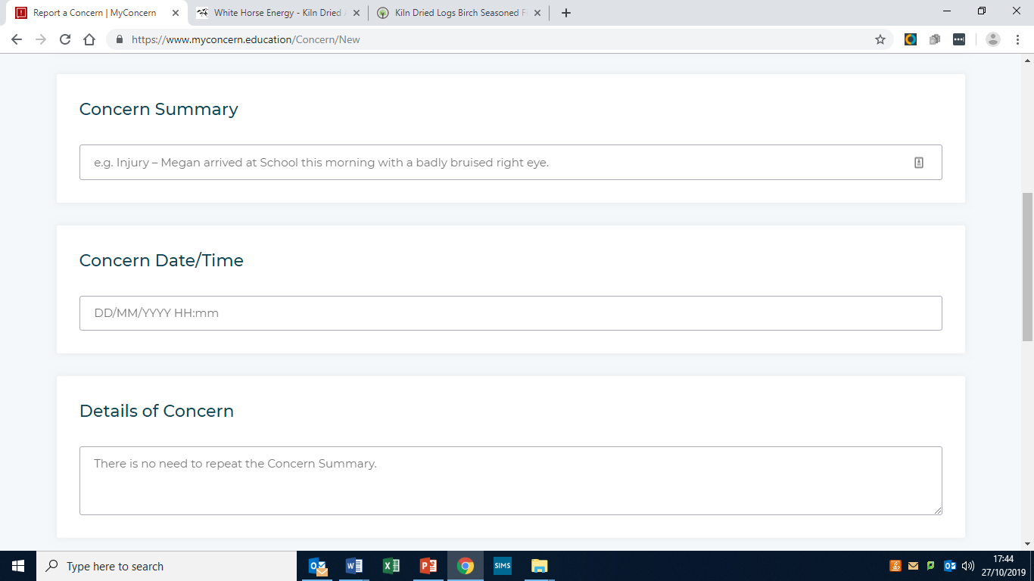

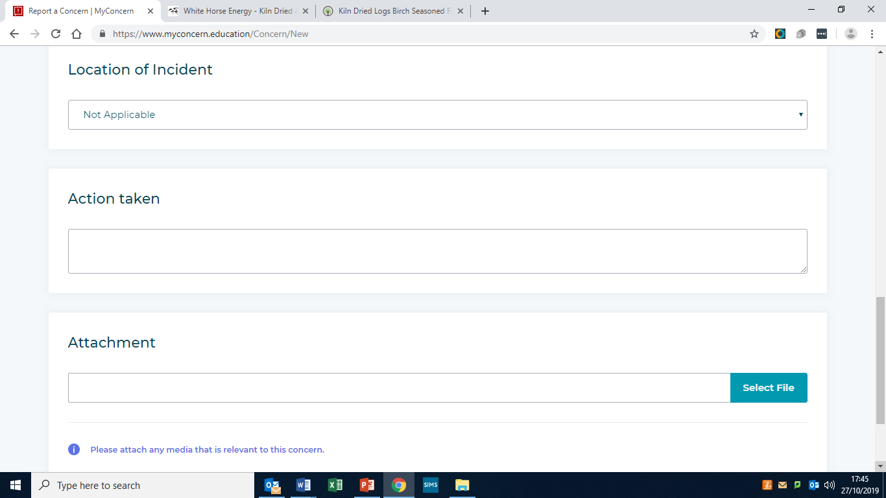

Appendix 5
Body Map

Member of staff referring: | Date:
Student name: | Year/Tutor group:

Please use in conjunction with child protection referral form. Locate and label any injuries outlined during the child protection disclosure process.

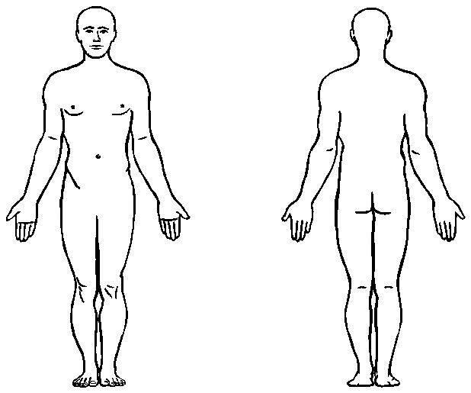

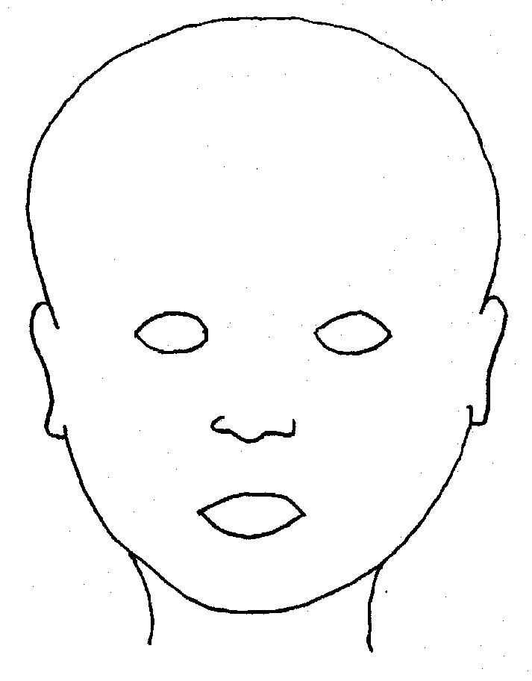

Appendix 6
Safeguarding and Child Protection: Expert Advice and Professional Organisations

Child Sexual Exploitation: https://www.gov.uk/government/publications/what-to-do-if-you-suspect-a-child-is-being- sexually-exploited

Bullying, including cyberbullying: https://www.gov.uk/government/publications/preventing-and-tackling-bullying

Domestic Violence https://www.gov.uk/domestic-violence-and-abuse

Drugs https://www.gov.uk/government/publications/drugs-advice-for-schools

Ealing Grid for Learning/Safeguarding http://www.egfl.org.uk/categories/student/safeguarding/

Fabricated or Induced Illness https://www.gov.uk/government/publications/safeguarding-children-in-whom-illness-is-fabricated-or- induced

Faith Abuse https://www.gov.uk/government/publications/national-action-plan-to-tackle-child-abuse-linked-to-faith- or-belief

Female Genital Mutilation (FGM) https://www.gov.uk/government/publications/female-genital-mutilation-multi-agency-practice- guidelines

Forced Marriage https://www.gov.uk/forced-marriage

Gangs and Youth Violence: https://www.gov.uk/government/uploads/system/uploads/attachment_data/file/226293/Advice_to_Sc hools_and_Colleges_on_Gangs.pdf

Gender-based violence/violence against women and girls (VAWG) https://www.gov.uk/government/policies/ending-violence-against-women-and-girls-in-the-uk

Mental health https://www.gov.uk/government/publications/the-mental-health-strategy-for-england

NSPCC: www.nspcc.org.uk

Private fostering https://www.gov.uk/government/publications/children-act-1989-private-fostering

Radicalisation https://www.gov.uk/government/publications/channel-guidance
Prevent and the Prevent Duty https://www.gov.uk/government/uploads/system/uploads/attachment_data/file/439598/prevent-duty-departmental-advice-v6.pdf

Sexting http://ceop.police.uk/

Teenage relationship abuse https://www.gov.uk/government/collections/this-is-abuse-campaign

Trafficking https://www.gov.uk/government/publications/safeguarding-children-who-may-have-been-trafficked- practice-guidance

See also links outlined in Keeping Children Safe in Education - Additional advice and support

https://assets.publishing.service.gov.uk/government/uploads/system/uploads/attachment_data/file/835733/Keeping_children_safe_in_education_2019.pdf

Appendix 7
Self-Harm – Immediate Intervention Flowchart

Elthorne Park High

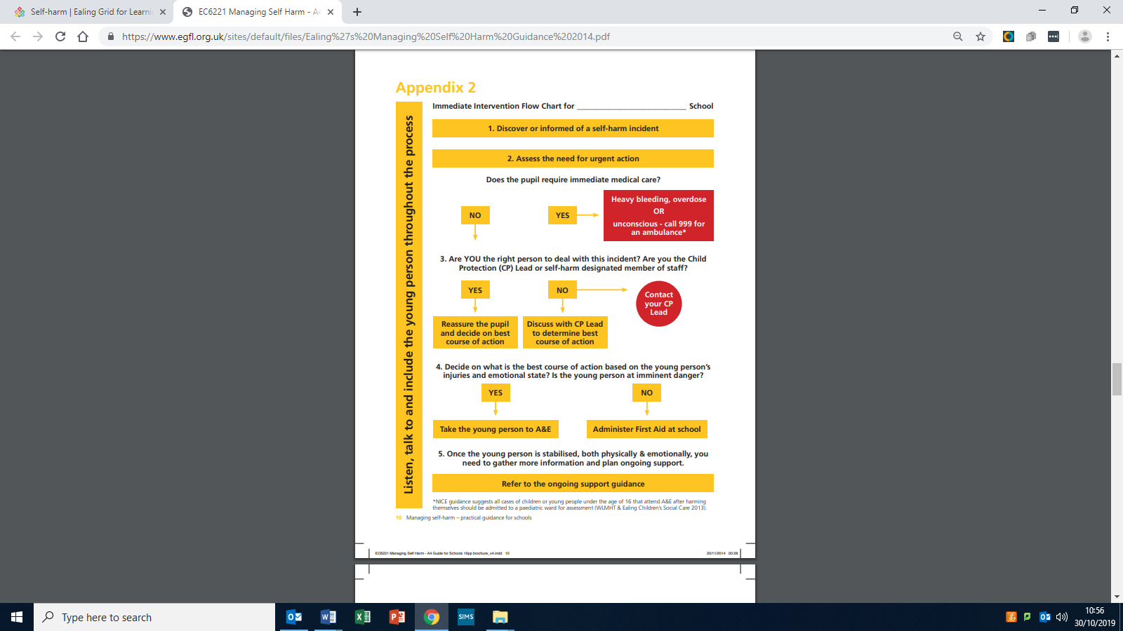
Appendix 8
Staff Response to an E-Safety Incident

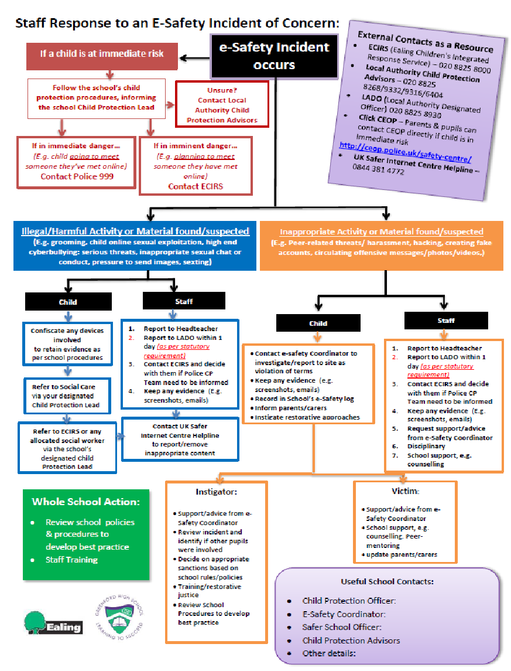Appendix 9
Confirmation of Receipt of Safeguarding and Child Protection Policy/Guidance and the Staff Code of Conduct

This form must be signed and returned by all staff working with students at the school

Name:

Position:

Confirmation of receipt of and understanding of the following statutory safeguarding documents:  - Safeguarding and Child Protection Policy  - Keeping Children Safe in Education (DfE) 2020 (chapter 1) and the  - Staff Code of Conduct | Please tick
I confirm that I have read and am aware of expectations and procedures outlined in Elthorne Park High School’s Safeguarding and Child Protection Policy.

I have read and am aware of the government’s statutory guidance in ‘Keeping Children Safe in Education’ (DfE 2020) guidance – section 1

I have received and am aware of the Staff Code of Conduct for staff working in education. (Ealing Local Authority)

Signature of staff member to confirm receipt of and awareness of expectations and procedures outlined in the safeguarding and child protection documents listed above:

Staff signature:

Date:

Please detach, sign and return this form to Wendy Henderson (Headteacher’s PA)

Appendix 10
Flowchart of Disclosure and Barring Service – Criminal record and barred list checks
Keeping Children Safe in Education 2020

