Elthorne Park High School



SMSC Policy

Adoption – November 2017
Review frequency - annual
Next review – November 2019
Status – Non-Statutory

Committee – Curriculum

INTRODUCTION

At Elthorne Park High School we recognise that for students to develop into mature, independent adults ready to take their place in society we must ensure that each student receives the best possible learning experiences, pastoral care and guidance experienced within the school’s spiritual, moral, social and cultural framework.

We actively promote the development of all students’ spiritual, moral, social and cultural development by providing positive experiences through planned and coherent opportunities in the formal and informal curriculum and through interactions with teachers, other adults and the local community.

The aim of this policy is to outline our whole school approach and opportunities for students’ SMSC development, so that the values inherent in our school ethos becomes a reality for the students.

The school has a carefully planned, comprehensive programme of PSHCE, together with a coherent assembly, tutor and extra-curricular programme; we endeavour to offer an inspiring and holistic experience to enable our young people to be Proud, Prepared, Persevering and Principled with a strong awareness of British values.

Scope including statutory requirements
- This policy was developed in response to National guidance – OFSTED Promoting and evaluating pupils’ spiritual, moral, social and cultural development 2004, the Education Reform Act 1988, the Education (Schools) Act 1992 and the School Inspections Act 1996.
- The policy also draws on DfE guidance outlined in ‘Promoting fundamental British values as part of SMSC in schools’ DFE-00679-2014.
- It also refers specifically to the most recent guidance from the Ofsted School inspection handbook (January 2015). It also takes into consideration the critical role SMSC has to play in ensuring our young people know how to be safe in an ever challenging world.
- It should be read in conjunction with other school policies on Equality, SEND, Safeguarding and Child Protection, Curriculum, Assessment, Teaching and Learning and the PSHCE schemes of work.

The statutory requirement that schools should encourage pupils’ SMSC development was first included in the Education Reform Act 1988. ‘The curriculum (must be) a balanced and broadly based curriculum which —
- promotes the spiritual, moral, cultural, mental and physical development of pupils
at the school and of society; and
- prepares such pupils for the opportunities, responsibilities and experiences of
adult life.’

This was followed by the Education (Schools) Act 1992 which stated that: ‘The Chief Inspector for England shall have the general duty of keeping the Secretary of State informed about the spiritual, moral, social and cultural development of pupils at those schools.’

All of the above guidance emphasises the need to establish the values schools should impart to pupils. It was clearly recognised that there is more to life than achieving high standards in academic subjects. The task was described as: ‘…the training of good human beings, purposeful and wise, themselves with a vision of what it is to be human and the kind of society that makes that possible’.

Elthorne Park High School aspires to be a school where pupils are encouraged to strive to “achieve excellence in a learning community” and foster a spirit of open and shared enquiry whilst developing their individual potential and qualities of character so they can make a positive contribution to the world.

Our Values
The following values and promoting these student attributes lay at the heart of all policy development in the school.
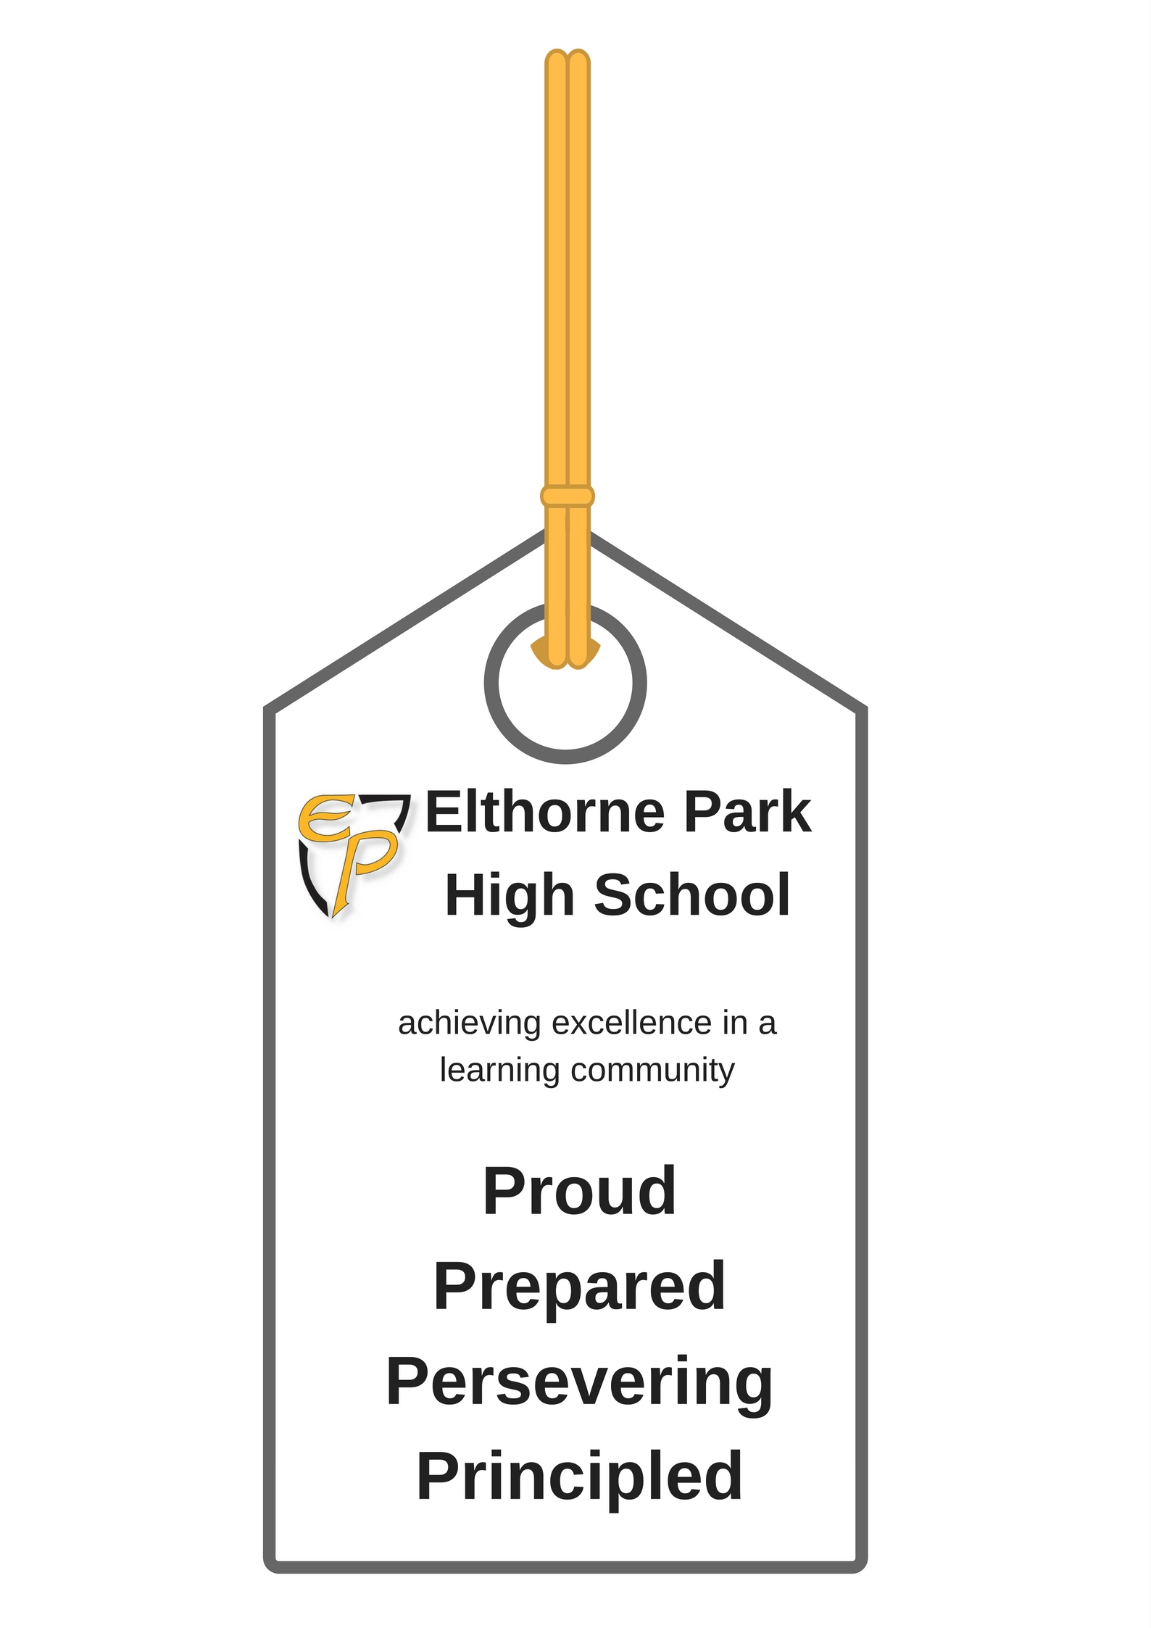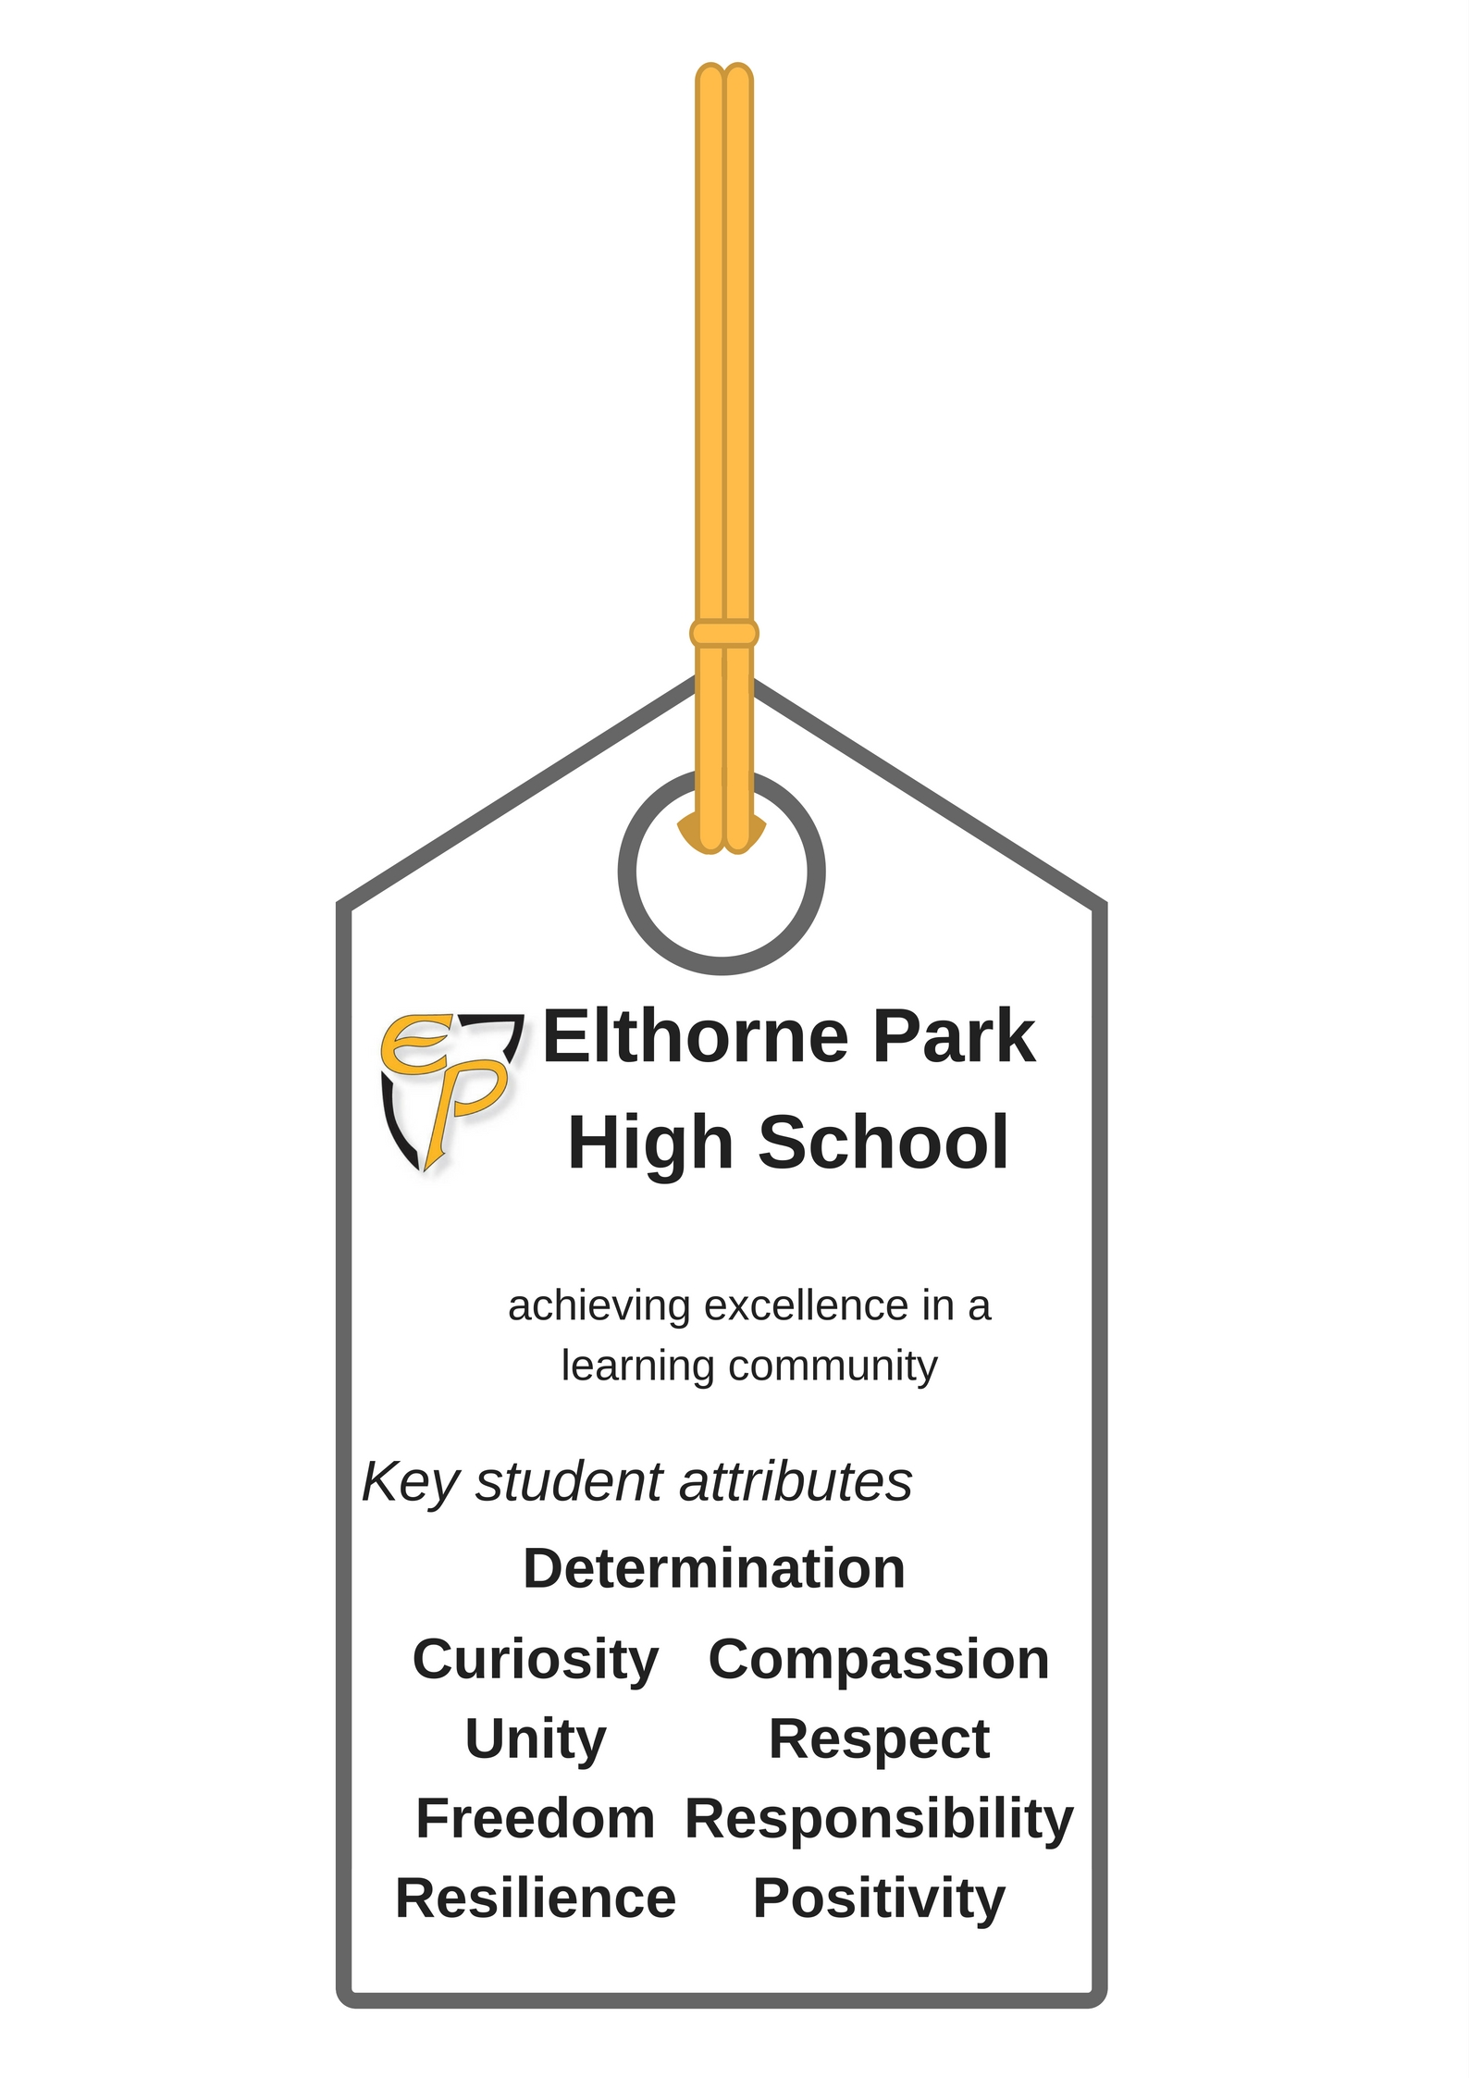

The school’s mission statement is
Achieving excellence in a learning community

We have four core values.

Proud - You are willing to celebrate your achievements and those of people around you.

Persevering - You won’t give up and will always ‘have a go’.

Principled - You know the difference between right and wrong. You have a strong sense of justice.

Prepared - You are ready and able to deal with the next stage in life.

We also have nine key attributes.

Positivity - You have a confident outlook on life.

Determination - You will not give up when things are difficult. You will keep going until you find a solution to the problem.

Resilience - You will be able to withstand stress and bounce back when you suffer a setback.

Unity - You are part of a community. You will work with us to achieve our shared goal of excellence.

Freedom - You understand freedom is choice. Freedom is where rights are balanced with responsibilities.

Compassionate - You understand the feelings of others and have a desire to help others.

Responsibility - You will do your share of the work and help others when they need help. You also have the responsibility to help make a better world.

Curiosity - You have a strong desire to learn. You want to find out more.

Respect - You know you are unique and valuable. You will listen to others and know others are valuable too.

For full definitions of “Spiritual”, “Moral”, “Social” and “Cultural” as they might apply to a school’s delivery please refer to Appendix 1.

Process and Practice

The PSHCE Co-ordinator (SMSC) will provide guidance and support for ensuring the below actions take place, working closely with the attached Deputy Headteacher.

In order to realise the above aims we will do the following:
- Provide a coherent assembly, tutor and PSHCE programme which enables all four aspects to be delivered at different and appropriate times.
- Provide opportunities for daily Acts of Collective Worship.
- Opportunities will also take place in extracurricular activities. Those with responsibility for running clubs, societies, trips and other events will develop their awareness of SMSC opportunities their activities have, and maximise the benefits they bring.
- Year based challenges (SMSC focus) provide opportunities for students to engage in a range of SMSC related activities including charity fund raising, voluntary work, school leadership opportunities and other community and personal challenges.
- At departmental level, Heads of Department/Faculty will regularly audit with their teams the opportunities for covering relevant SMSC criteria in their Schemes of Work.
- Promote student voice and the poser of democracy via the School Student Council.
- Those with responsibility for publicising the School or liaising with other schools and organisations should consider the SMSC aspects of their public relations. In addition to being representatives of the School, they should report SMSC matters arising from their links to the School at appropriate occasions.
- At pastoral level, the Pastoral Team and groups of tutors will regularly discuss SMSC issues and appropriate thought will be given about how aspects of these issues may be best communicated to members of staff, to pupils and parents, and to other interested individuals.
- The Assistant Headteacher with responsibility for SMSC with the Deputy Head teacher will be responsible for overall delivery ensure that individual and whole staff SMSC needs are mapped and delivered as part of the wider school curriculum and day to day life of the school.
- All Members of Staff should be aware of the importance of SMSC development and the enhancement it brings to the life of the School. They should feel free to voice related concerns and interests within the normal pattern of departmental, tutorial and staff meetings.

Developing the Moral & Spiritual
During their time at Elthorne Park High School students will be provided with opportunities across the curriculum to:
- Discuss matters of personal concern
- Engage in discussions about moral dilemmas
- Stimulate their curiosity, imagination and creativity
- Develop positive relationships with each other and with adults
- Develop a sense of belonging and community
- Explore the beliefs and values of others
- Develop and understand their own beliefs, and personal views
- Acquire and practice the skills of reflection
- Meet a wide range of aesthetic experiences
- Understand why people reach certain decisions about moral and spiritual issues and how these decisions affect their lives
Again this area will require further mapping by subject leaders to identify opportunities for delivery.

Collective Worship
At Elthorne Park High School the aims of collective worship are:
- To promote, interpret and put into practice the school aims and values
- To celebrate the achievements of the school community
- To consider ideas and beliefs and their relevance to their own lives
- To develop a sense of community
- To think about the needs of others
- To provide opportunities for pupils to reflect and contemplate
- To celebrate diversity & inclusion
An annual ‘assembly programme’ has been carefully developed to provide a framework for assemblies throughout the year. Each Year leader is given flexibility to divert from this to provide SMSC support required by students at specific times throughout the year.
Delivery Across All Subjects of the Curriculum
The knowledge and understanding essential to both spiritual and moral development, and the ability to make responsible and reasoned judgements should be developed through all subjects of the curriculum.
Within the curriculum pupils will encounter questions about the origins of the universe, the meaning and purpose of life, the nature of proof and certainty, and the nature of humanity. Religious studies will have an important part to play in addressing questions of creation, meaning and purpose through the study of the major world religions.
Pupils will also be presented with opportunities to encounter and discuss moral issues. For example such opportunities will occur in:
Science (issues of life and death-abortion, IV fertilisation, smoking and drugs; energy and environmental issues)
Humanities (environmental issues, issues of justice and equality-distribution of wealth, racial inequality, war and peace)
English (moral and spiritual issues occur throughout literature)
Technology (issues of wealth and distribution, alternative technology, the use of world resources)
Drama (issues of equality, moral dilemmas, trust and responsibility)
PSHCE (issues of equality, gambling, smoking and drugs, justice and freedom)
RS and Citizenship (questions about right and wrong, differing religious perspectives)
Teaching and Learning Strategies
The most appropriate teaching and learning strategies are those which:
- Involve pupils in their own learning
- Enable pupils to work co-operatively and collaboratively
- Enable pupils to discuss and share their views in a safe and supportive environment
- Place new learning in the context of previous experience
- Explore currently held personal and cultural beliefs and values in the context of new learning
- Apply new learning to other situations
- Actively consider the implications of this learning for themselves, for society and for the environment
Important Principles for Personal and Social Development
- Personal and social development is an entitlement of all pupils
- The personal and social development of pupils is the responsibility of all staff and should take place throughout the curriculum.
- Year leaders are responsible for the personal and social development of pupils within their year group.
- The PSHCE Co-ordinator has responsibility for co-ordinating the taught PSHCE programme in consultation with Year Leaders.
- Heads of Faculty and subject leaders are responsible for ensuring that their subject curriculum contributes to the whole school development of pupils’ personal, moral, social and spiritual development.
- The assigned Assistant Headteacher with responsibility for PSHCE and the Deputy Head has overall responsibility for ensuring coverage, coherence and progression
Cultural Development
At Elthorne Park High school, pupils are provided with an opportunity to learn about and celebrate British values and culture and the wide range of cultures and ethnic backgrounds that make up our diverse school community.

Pupils develop an awareness of their own cultural roots and British Values across the curriculum. (British Values: EPHS curriculum mapping document 2017)

Pupils are also provided with opportunities to appreciate the diversity and evolution of cultural traditions within society and their local community, how conflicts sometimes occur, and how they can be reconciled.

The cultural development of pupils is shown by their exposure to the following across the formal and informal curriculum:
• Understanding and appreciation of the wide range of cultural influences that have
shaped their own heritage and that of others
• Understanding and appreciation of British Values and the range of different cultures
within school and further afield as an essential element of their preparation for life
in modern Britain
• Knowledge of Britain's democratic parliamentary system and its central role in
shaping our history and values, and in continuing to develop Britain
• Willingness to participate in and respond positively to artistic, sporting and cultural
opportunities
• Interest in exploring, improving understanding of and showing respect for different
faiths and cultural diversity, and the extent to which they understand, accept,
respect and celebrate diversity, as shown by their tolerance and attitudes towards
different religious, ethnic and socio-economic groups in the local, national and
global communities.

Monitoring and Evaluation

Responsibility for SMSC policy review and implementation:

Governor with Responsibility for SMSC
Deputy Headteacher – Curriculum  SMSC Policy Review Lead | David White
Assistant Headteacher – Values & Student Culture | M Myers
Assistant Headteacher – PSHCE Curriculum | H Thomas

The policy will be reviewed bi-annually led by the Deputy Headteacher and Curriculum Committee following consultation with stakeholders.

Information and data will be collected at regular points throughout the year relating to its delivery and practice using a variety of ways including:

- Lesson observations and learning walks.
- Curriculum content
- Student interviews,
- Student and parent survey.
- Student council feedback.
- Regular auditing of departmental schemes of work by members of the Senior Leaderships team.
- Monitoring of Assemblies and Tutor Time activities.
- Monitoring of the school’s extra-curricular activities programme including student uptake.
- Monitoring of trips and visits including student attendance.
- Wider departmental, pastoral and whole school self-evaluation.
- Feedback from visitors and members of the local community.
- Day to day interactions in lessons at playtime and around the school site.

Appendix 1
What is SMSC?

The school, incorporating the Ofsted definitions below, link a meaningful and coherent programme of delivery underpinned by its ethos.

Spiritual Development

Spiritual development is the development of the non-material element of a human being which animates and sustains us and, depending on our point of view, either ends or continues in some form when we die. It is about the development of a sense of identity, self-worth, personal insight, meaning and purpose. It is about the development of a pupil’s ‘spirit’. Some people may call it the development of a pupil’s ‘soul’; others as the development of ‘personality’ or ‘character’. As children develop physically they do so emotionally and psychologically. In studying at school to gain knowledge and skills their personal beliefs and identities are shaped.

Moral Development

Moral development is about the building, by pupils, of a framework of moral values which regulates their personal behaviour. It is also about the development of pupils’ understanding of society’s shared and agreed values. It is about understanding that there are issues where there is disagreement and it is also about understanding that society’s values change. Moral development is about gaining an understanding of the range of views and the reasons for the range. It is also about developing an opinion about the different views. Children enter secondary school with degrees of moral understanding defined by their families and friends and by their previous schooling. They should be encouraged to take personal responsibility for their words and actions. They should be expected to reject any form of bullying, discrimination or cruelty. They should be helped to deal with any moral dilemmas they may face.

Social Development

Social development is about young people working effectively with each other and participating successfully in the community as a whole. It is about the development of the skills and personal qualities necessary for living and working together. It is about functioning effectively in a multi-racial, multi-cultural society. It involves growth in knowledge and understanding of society in all its aspects. This includes understanding people as well as understanding society’s institutions, structures and characteristics, economic and political principles and organisations, roles and responsibilities and life as a citizen, parent or worker in a community. It also involves the development of the inter-personal skills necessary for successful relationships.

Cultural Development

Cultural development is about pupils’ understanding their own culture and other cultures in their town, region and in the country as a whole. It is about understanding cultures represented in Europe and elsewhere in the world. It is about understanding and feeling comfortable in a variety of cultures and being able to operate in the emerging world culture of shared experiences provided by television, travel and the internet. It is about understanding that cultures are always changing and coping with change. Promoting pupils’ cultural development is intimately linked with schools’ attempts to value cultural diversity and prevent racism.

