**Revision Instructions**

There are two main ways to revise Government and Politics.

1. Use the revision templates that have been explained to you in class to create a collection of topic summaries.

|  |
| --- |
| Fill in with the topic you are revising – use the title from the textbook. This may have been pre-written for you. |
| Summarise the basics of the topic – brief definition |
| The three boxes need to be short facts/quotes/pieces of important knowledge. You must think hard about what you choose to put into these boxes. They should be things you could remember in an exam. One of these should from ‘current’ political life. |
| Copy down the key terms. |
| These should be arguments for and against that you could later form into essay paragraphs. |
| Is there anything else from the topic you think might be necessary to remember? |

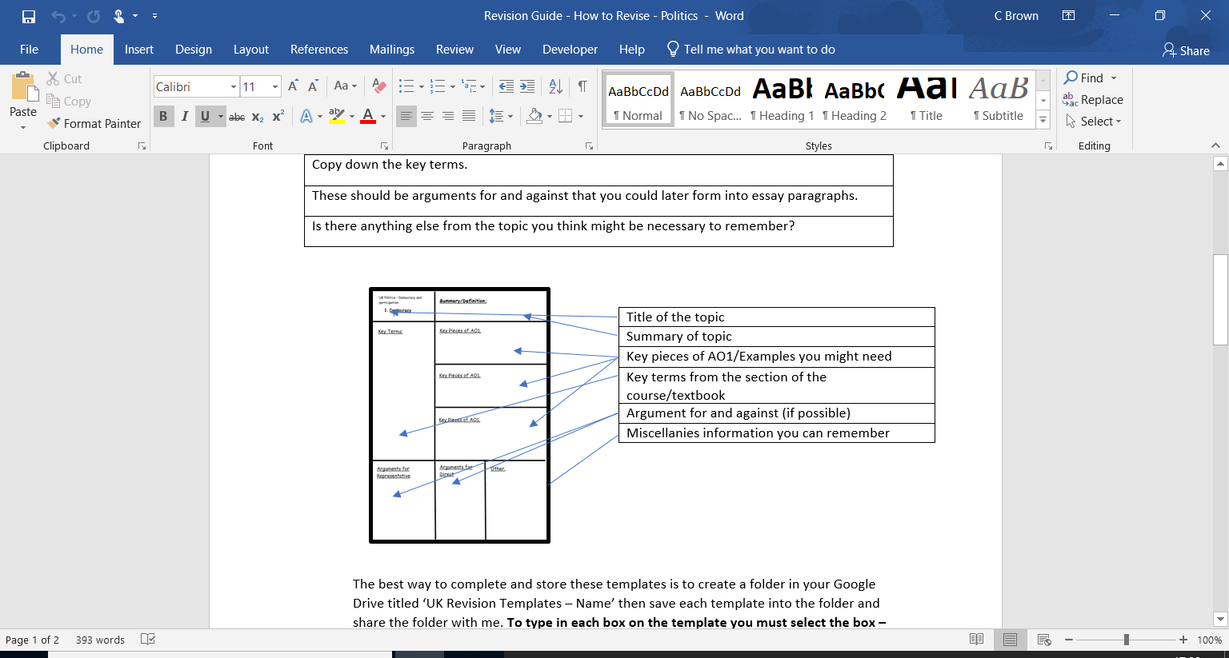

**THESE REVISION TEMPLATES ARE ON GOOGLE CLASSROOM**

The best way to complete and store these templates is to create a folder in your Google Drive titled ‘UK Revision Templates – Name’ then save each template into the folder and share the folder with me. **To type in each box on the template you must select the box – click edit and then insert a text box to type into.**

1. The second way to revise Politics is to complete essay plans to improve your 24 and 30 markers.

|  |
| --- |
| Follow instructions given for each section. |
| The notes sections will give you reminders of what the purpose of your writing should be. |
| This section should be as detained with information as possible. You may leave out the language around your points but this plan should be as useable as possible. |
| The paragraph might be very simple and should usually consist of your knowledge of humanism and how they would disagree with the religious perspective. |
| The conclusion should be a summation of the arguments you have written in your essay. Finally, you can explain your own opinion of the statement. |

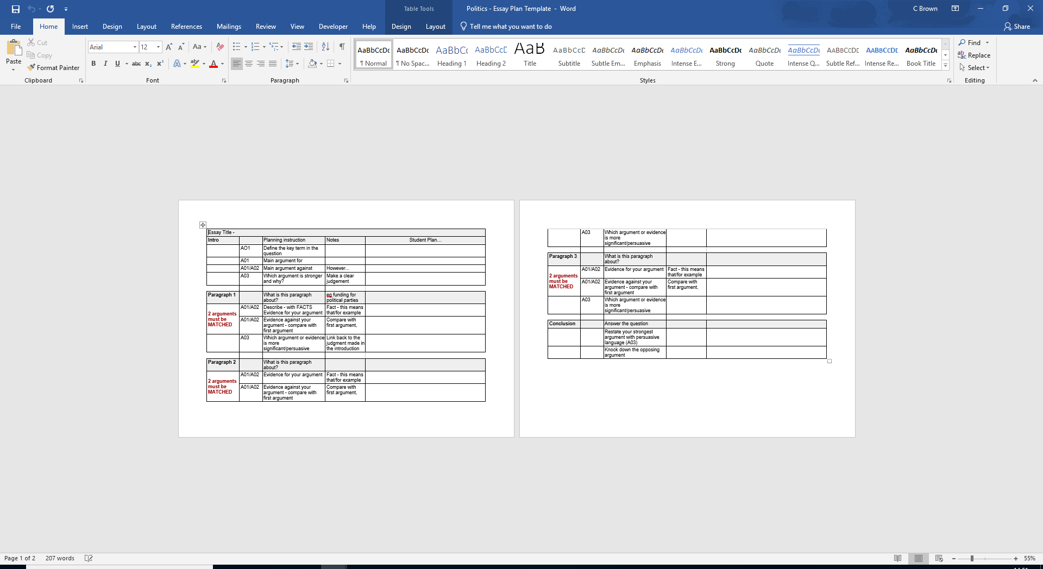



**Super Curricular Reading List**

The most highly recommended resource of all (because it succeeds so well in providing intelligent analysis which is accessibly written without it being dumbed down) is <https://www.bbc.co.uk/news/politics>

Try the other reading/listening/watching recommendations below, with the intention of continuing with what you find useful and enjoyable. **Few subjects can offer such current and entertaining homework**

**Newspapers** (create an app on your phone)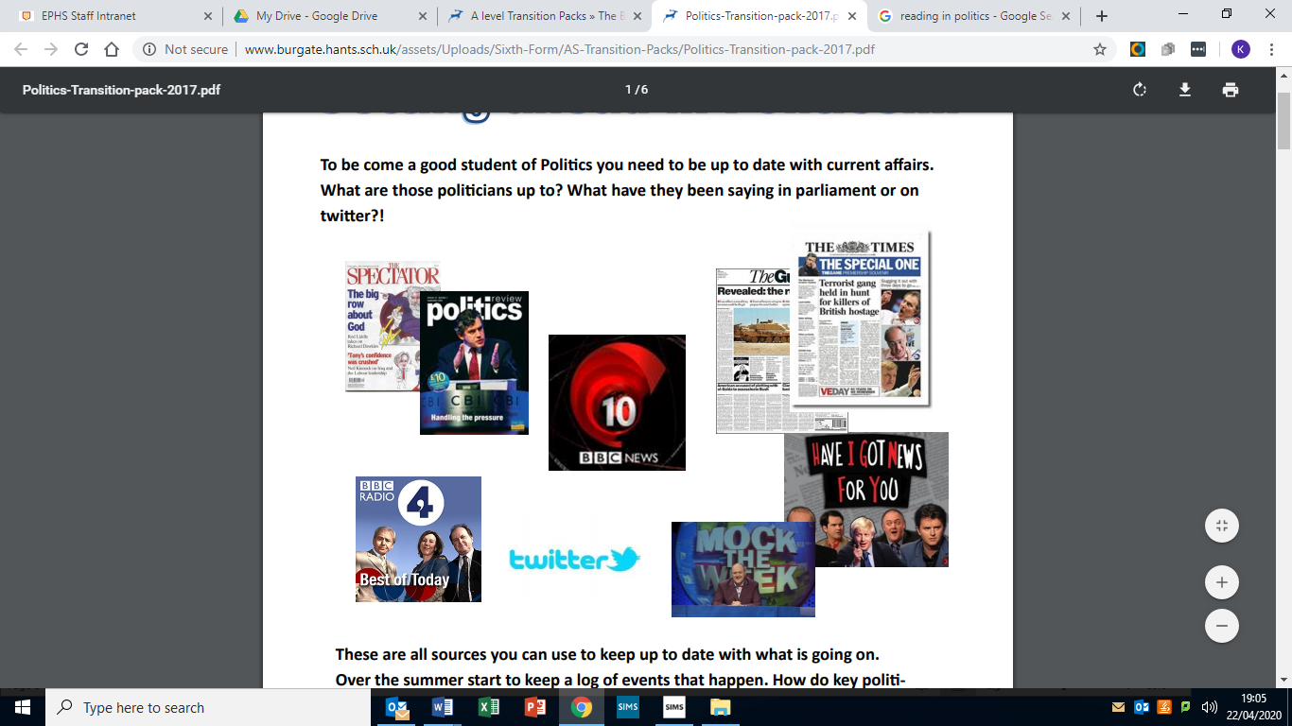

The Guardian

The Independent

The Daily Mail

The Telegraph

New York Times

Washington Post

**TV and Radio** (and there are a lot of daily podcasts you can find)

*Please be aware that these programmes are not available throughout the year and that schedules may change*

Monday – Friday – Newsnight BBC2

Thursday – Question Time BBC1

Friday – Have I got News for You BB1, The News Quiz Radio 4

Saturday – A Week in Westminster Radio 4

Sunday – The Andrew Marr Show BB1

UK Politics

Essentials of UK Politics by Andrew Heywood

Global Politics by Andrew Heywood

The Road to 1945 by Paul Addison

The Blair Legacy by Terrence Casey Thatcher

Thatcherism by E. Evans

For the Record by David Cameron

Core Ideologies reading list

|  |  |
| --- | --- |
| Author | Title: |
| Socialism | |
| Aneurin Bevan | In Place of Fear |
| Steven Jones | Antonio Gramsci |
| Jeremy Gilbert | Twenty-First Century Socialism - Radical Futures |
| Conservativism | |
| Roger Scruton | How to Be a Conservative |
| E. H. H. Green | The crisis of conservatism |
| Christopher Ellis and James Stimson | Ideology in America |
| Liberalism | |
| Patrick Deneen | Why Liberalism Failed |
| A collection of writers | Liberalism as Ideology: Essays in Honour of Michael Freeden |
| Edmund Fawcett | Liberalism: The Life of an Idea |
| Nationalism | |
| Anthony D. Smith | Nationalism |
| Giuseppe Mazzini | A Cosmopolitanism of Nations: |
| Ernest Renan | What is a Nation? |

**Background Watching for understanding and outside AO1.**

|  |  |  |  |
| --- | --- | --- | --- |
| **Labour Party** | Rise and fall of the Labour Party | <https://www.youtube.com/watch?v=ArnmL82u2Ig> |  |
|  | Blair & Brown The New Labour Revolution | <https://www.youtube.com/watch?v=ANirM3s2JpQ> |  |
|  | How united are the Labour Party? | <https://www.youtube.com/watch?v=2ewQzUyp3Og> |  |
|  | Labour Party: Keir Starmer’s Road to Power | <https://www.youtube.com/watch?v=FrSENJs6Bm0> |  |
| **Conservaive Party** | Conservative Party in the 1950s | <https://www.youtube.com/watch?v=NvbwV3rRbRA> |  |
|  | 'Our Maggie' | <https://www.youtube.com/watch?v=OvCIBIC69c8> |  |
|  | David Cameron | <https://www.youtube.com/watch?v=ZDOkv5K-j8A> |  |
|  | When Boris met Dave | <https://vimeo.com/269620748> |  |
| UK Politics - Grassroots | Are the Tories losing their suburban heartlands? | Anywhere but Westminster | <https://www.youtube.com/watch?v=qPbU2sxzGO4> |  |
|  | Labour’s Red Wall: the places that will decide the election | Anywhere but Westminster | <https://www.youtube.com/watch?v=23J3yB5Mmjg> |  |
|  | A tale of two Kensingtons: London and Liverpool... and the 2015 election's inequality gap | <https://www.youtube.com/watch?v=azSK-d1VHPc> |  |
|  | Scotland: fear and Lothian on the campaign trail | Anywhere but Westminster | <https://www.youtube.com/watch?v=t7Y02-03ZFU> |  |
|  | Border line: a journey through the Irish heart of the Brexit crisis | <https://www.youtube.com/watch?v=QkjxkKYrEyE> |  |
| Brexit - An Education | How Did Brexit Happen? | History | <https://www.youtube.com/watch?v=_JTz9Lnw0cA> |  |
|  | Nigel Farage's biggest BUST-UPS in the EU Parliament | <https://www.youtube.com/watch?v=1zyHU4SkLMA> |  |
|  | Why Brexit happened -- and what to do next | Alexander Betts | <https://www.youtube.com/watch?v=dcwuBo4PvE0> |  |
|  | Brexit: What will happen to Ireland? | <https://www.youtube.com/watch?v=fH42ZktzfeE> |  |
| **How does Parliament work?** | How does Parliament work? | <https://www.youtube.com/watch?v=HAmnhlk8WFg> |  |
|  | Most of Britain's Parliament is not elected... Meet THE LORDS | <https://www.youtube.com/watch?v=xgMRiA9dZQs> |  |
|  | Take a tour of the House of Lords | <https://www.youtube.com/watch?v=_sLZBWcPklk> |  |
|  | The UK's Constitution Explained | <https://www.youtube.com/watch?v=ZwLgjUPQCMY&t=170s> |  |
|  | How Do Laws Get Passed In The UK? | <https://www.youtube.com/watch?v=g5CJNLRqZXs> |  |
| **Scotland** | Scottish independence: could Britain break up? | <https://www.youtube.com/watch?v=kBHZiXUDV6A> |  |
|  | Rise of the SNP: the inside story | <https://www.youtube.com/watch?v=eacbNSv1l3c> |  |
| **Prime Minister of old** | Clement AttleeHow did Churchill lose the 1945 general election? | <https://www.youtube.com/watch?v=zCNkahrivc8> |  |
|  | Clement Attlee asks the public to help renew Britain (1946) | <https://www.youtube.com/watch?v=GXp0ISX5804> |  |
|  | The Foundation of the National Health Service | <https://www.youtube.com/watch?v=0pnEMBgEG24> |  |
| Ted Heath vs Harold Wilson | Heath vs Wilson - The 10 Year Duel - Part 1 | <https://www.youtube.com/watch?v=WGiQ4YLMyN0> |  |
|  | Heath vs Wilson - The 10 Year Duel - Part 2 | <https://www.youtube.com/watch?v=oS1GGc_SeRc> |  |
|  | Heath vs Wilson - The 10 Year Duel - Part 3 | <https://www.youtube.com/watch?v=JngRKiyBhWo> |  |
|  | Heath vs Wilson - The 10 Year Duel - Part 4 | <https://www.youtube.com/watch?v=zDIYW76WBpo> |  |
|  | Heath vs Wilson - The 10 Year Duel - Part 5 | <https://www.youtube.com/watch?v=piTwHY7qwXE> |  |
|  | Heath vs Wilson - The 10 Year Duel - Part 6 | <https://www.youtube.com/watch?v=TE2KrnUtfGU> |  |