

Schools

Counselling Partnership

# Supporting children, families and schools .

**Meet your SCP Team**

Please feel free to catch us to say hello and introduce yourself anytime!

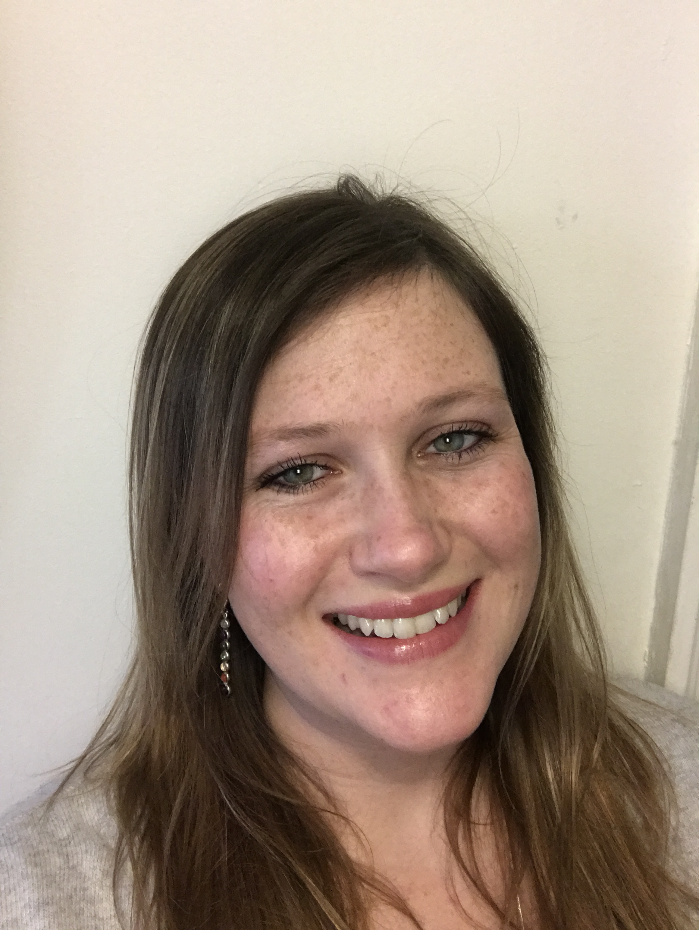

**Michelle Hanafi**

**Clinical Lead – SCP**

**Therapuetic Lead - Elthorne**

**Mondays, Thursdays & Fridays**

[michelle@schoolscounsellingpartnership.co.uk](mailto:michelle@schoolscounsellingpartnership.co.uk)

07469714459



**Anita Bravin**

**Child & Adolescent Psychotherapist**

**Mondays & Fridays**

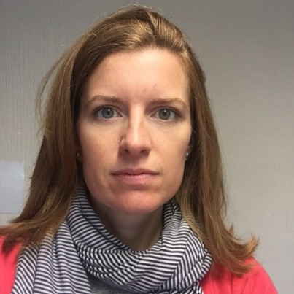

**Dorothy McNiel**

**Child & Adolescent Psychotherapist**

**Thursdays**